

Department of Computer Science

COMP4300 - Graduation Project

Making A Change Through Boycott

**Project No:**

5

**Supervised By:**

Dr. Samer Al-Zein

**Prepared By**

Osid Abu Al-Rub (1183096)

Hamzeh Hawwash (1180470)

Hashem Abu Al-Teen (1172660)

# Abstract

Nowadays, a lot of people can find themselves at a disadvantage facing a higher company or person, and usually have no effective ways of going against them except for boycotting, which can be considered as the best way to demand changes in a non-violent way. There are a lot of examples of successful boycotts that have happened over the years, such as the Iranian Tobacco Boycott in 1891, and the boycott that China did against the Japanese products in the May fourth movement. So, the examples are endless, but not nearly enough people consider boycotting as an option of resistance. And if they consider it, it’s still a tremendous task to find people who also want to support and join the boycott, and also finding the products that align with one's belief is very difficult. Making the process of spreading the news about the boycott and getting new people introduced to the movement/boycott a whole lot more complicated. This is why we’ve created this project. In this project, we developed a mobile application that will make it easier for people to discover, participate, and make a change. They can also have the news about a boycott be concentrated in one place via the campaigns that the application provides, which are groups of like-minded people who are also passionate about the same movement. Finally, the application helps the users to determine if a product supports their boycott/campaign or not.

# Table of Contents

## Contents

Abstract I

Table of Contents II

Contents II

List of Figures VII

List of Tables X

Acknowledgements XI

Chapter 1: Introduction 1

1.1) Overview 1

1.2) Aims and Objectives 2

1.3) Motivation 2

1.4) Technologies Used 2

1.5) Report Structure 3

Chapter 2: Background Information 4

2.1) Adobe XD 4

Repeat Grid 5

Components 6

2.2) React-Native 7

React Native Under the Hood 8

Advantages of React Native 8

Cons of React Native 9

Javascript Syntax Extension (JSX) 10

2.3) Node JS 11

Non-thread Blocking 11

Event Loop 11

2.4) Typescript 12

2.5) MySQL 13

2.6) Amazon Web Services (AWS) 14

AWS Relational Database Service 15

Advantages 15

2.7) Postman 16

API user interface 16

2.8) Barcodes 17

Barcode numbers 17

Types of Barcodes 18

3.1) Similar apps 19

3.1.1) Buycott – Barcode Scanner Vote 19

Pros of Buycott 22

Cons of Buycott 22

Differences 23

3.1.2) QR and Barcode scanner 24

Features 24

Differences 27

3.1.3) Facebook 27

Differences 30

3.1.4) Summary of features 31

3.2) Literature Review 33

3.2.1) Does boycotting actually work? 33

What is boycotting? 33

Outcomes of boycotting 33

Successful boycotts 34

Conclusion 34

3.2.2) What is the purpose of using Facebook? 34

3.2.3) Why do people participate in boycotts 35

Chapter 4: System Analysis 37

4.1) Use case diagram 37

4.2) User-system requirements 38

4.3) Class Diagram 43

4.4) Activity Diagrams 44

4.4.1) Creating account activity 45

4.4.2) scanning the product activity 46

4.5) Sequence Diagrams 46

4.5.1) Scanning a product 47

4.5.2) Filtering 47

4.6) Software architecture 48

Chapter 5: System Design 50

5.1) User Interface: 50

5.1.1) Sign in Interface 50

5.1.2) Sign Up Interface 52

5.1.3) Feed Interface 53

5.1.4) Sidebar Interface 54

5.1.5) Post Interface 55

5.1.6) Search Interface 55

Chapter 6: Implementation & Testing 57

6.1) Implementation 57

6.2) Testing 70

6.2.1) Manual Testing 71

6.2.2) API Testing 75

76

Chapter 7: Discussion 77

Chapter 8: Challenges & Conclusion 78

8.1) Challenges 78

Images 78

Database Export/Import 78

Products Import from Excel Sheet 78

Data Validation 78

Filtering 79

Debugging 79

8.2) Conclusion 79

8.3) Future Work 79

References 81

Appendices 83

# List of Figures

Figure 1: Adobe XD UI 4

Figure 2: Copy of Design 5

Figure 3: Horizontal and Vertical Alignment 6

Figure 4: Main and Instance Components. 7

Figure 5: How React Native Works 8

Figure 6: React Native Advantages 9

Figure 7: JSX Example 10

Figure 8: The Event Loop 12

Figure 9: Vin Diagram of Typescript 13

Figure 10: MySQL Logo 14

Figure 11: AWS logo 15

Figure 12: Postman logo 16

Figure 13: Postman UI 17

Figure 14: Types of Barcodes 18

Figure 15: Explore and Join Campaigns 19

Figure 16: Suggest a Product 20

Figure 17: Scanning a Product 21

Figure 18 Trending Campaigns and Recent Actions 22

Figure 19: Slow Loading and Errors 23

Figure 20: Main Page 24

Figure 21: Favorite Scans 25

Figure 22: Create Code 26

Figure 23: History View 27

Figure 24: Screenshot of a Post 28

Figure 25: Screenshot of a Facebook Profile 29

Figure 26: Screenshot of a Group Post 30

Figure 27: Boycott Motivations 35

Figure 28: Use Case Diagram 38

Figure 29: Class Diagram 44

Figure 30: Create Account Activity Diagram 45

Figure 31: Scan Product Activity Diagram 46

Figure 32: Scanning a Product 47

Figure 33: Filtering Campaigns 48

Figure 34: Software Architecture 49

Figure 35: Sign in Interface 51

Figure 36: Sign Up Interface 52

Figure 37: Feed Interface 53

Figure 38: Sidebar Interface 54

Figure 39: Post Interface 55

Figure 40: Search by Filter 56

Figure 41:Signup interface 57

Figure 42: Login Interface 58

Figure 43: Invalid credentials message 59

Figure 44: Feed interface 60

Figure 45: Liked & unliked post 61

Figure 46: Comment section interface 61

Figure 47: Campaigns view 62

Figure 48: Barcode scanner 63

Figure 49: No camera access 64

Figure 50: Scanned product found 65

Figure 51: Add product interface 66

Figure 52: Notifications interface 67

Figure 53: Personal profile interface 68

Figure 54: Filter interface 69

Figure 55: Create post interface 70

Figure 56: Test sample 76

# List of Tables

Table 1: Feature comparisons 32

Table 2: User Requirements 39

Table 3: Manual tests 71

# Acknowledgements

We’d would first of all like to thanks Dr.Samer for his great efforts over the past year. He was continuously meeting with us to give us advice and make sure we are on the right track.

We can’t forget our families, the ones that stood beside us to ensure everything was going well, and made sure to provide the right environment for us to flourish.

Finally, we’d like to thank our friends and colleagues for helping us technically by giving us some advices from time to time.

# Chapter 1: Introduction

## 1.1) Overview

Mobile applications are quickly becoming more omnipresent, used anywhere and everywhere, making it easier to connect to people and share news between them, which is why we believe, if executed successfully, we can use this power to assist people in making, participating, and sharing a better future via boycotts. An Example of a boycott of products occurred and started on October 22, 2020, when the Arab community got together and decided to boycott French products, because of their constant disrespectful behavior towards the prophet Mohammed**ﷺ** . They urged the French government to apologize and claim that no offense was meant to take place­ [1].

So, how does our application work? And how does it help people with boycotts? The user starts by signing in/registering into our application using his preferred email, in addition to some extra personal info when registering. After that the user can choose between viewing ongoing boycotts, creating one themselves, or participating in existing boycotts. The user is also able to share boycotts and movements to other social media apps like Facebook or Twitter. Furthermore, the user can participate in something called campaigns, which are (put lightly) a community of like-minded people. These communities grow people closer to their cause and makes it really easy for them to always be up to date about anything that they support or care about. Additionally, the user can scan a barcode to view the product’s info and any boycotts related to it, which is useful for the user to know if the product is good for their campaign or not. On top of that, the user can view campaigns/boycotts from all over the world, not just in his/her country. Which is good for people who are trying to enlighten themselves about world issues.

The application is not meant to be a social media app, it’s meant to give people the ability to make their voices heard, and give them the ability to represent themselves and overshadow their governments.

## 1.2) Aims and Objectives

The motivation and objective of this application is to make people’s voices heard, to give the ability for humans with kind hearts and enlightened minds to make the change they want to do around the world without the need to be physically there. Ultimately, our aim is to be the stepping stone for the public to know occupation state products and boycott it in specific, and the other products in general.

## 1.3) Motivation

The program is needed because social media apps take a lot of time out of people’s days, and they don’t focus on change, they instead focus on wasting, consuming, and monetizing people’s time. And that’s not the case in our application, our motivation is to give the space for exploration in the short term, and focus mainly on actions in the long term.

What you should expect is a simple application that delivers people’s voices and identifies unwanted products from occupation state specifically, and from any other oppressing voice generally. This is needed because it’s very difficult for people to identify what products harm their causes/beliefs.

## 1.4) Technologies Used

Many technologies can be used to build such an application like this one. But considering the timeframe and scalability aspects, the following technologies are considered to be the best fit for our cause and goals:

* **Adobe XD:** A UI/UX design tool that is vector-based.
* **React Native:** write Javascript for android, IOS, and web from a single codebase.
* **Nodejs:** It’s a way for the developer to write and run Javascript on the server-side
* **Typescript:** A superset of Javascript that builds upon it by giving you types.
* **MySQL:** Relational database management system built on structured query language.
* **AWS:** A collection of could computing services.
* **Postman:** API testing tool.

## 1.5) Report Structure

The incoming structure for the report is simple, chapter two will mainly focus on the background information for the project/application. This means we dive deeper into the technologies used and so on. Chapter three will take a look at some related work that is kind of similar to what we are trying to do. Chapter four will be about system analysis, so diagrams, and user-system requirements. Chapter five will be the system design of the application. Finally, chapter six will be the conclusion of all the work and complexities we faced during the development.

# Chapter 2: Background Information

## 2.1) Adobe XD

It is a design tool that is vector-based, which means the output is an artwork that is made of lines, points, and curves, and not pixels. And this gives us the ability to zoom in or out as much as we want without losing the quality of the artwork. Adobe XD can be used to create simple UI like smartwatch apps to fully-fledged websites [2].

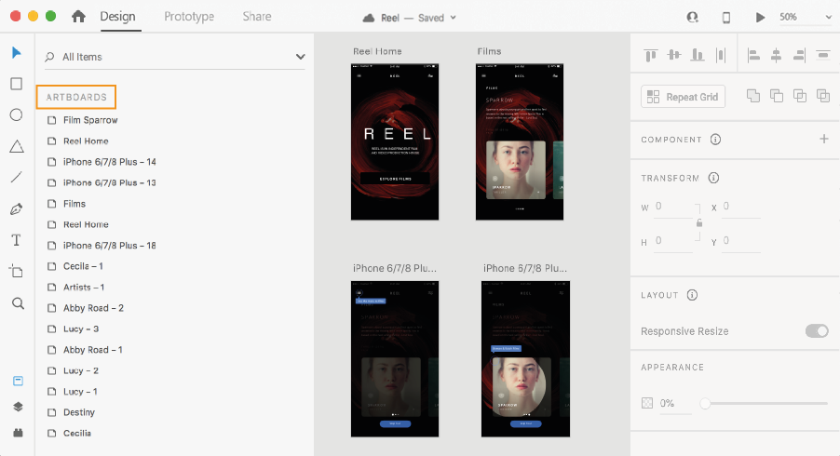

Figure 1: Adobe XD UI

As shown in **Figure 1,** this is the general user interface of Adobe XD. It’s very beginner-friendly and isn’t cluttered as one might expect.

Adobe XD was first introduced in 2015, as a saving grace for all those designers who were using photoshop and adobe illustrator for their designs. Adobe XD came with a lot of features that were not existent before, like prototypes, animations, components, plugins, responsive resizing, and repeat grid. And these are just a few of the Adobe XD features [3].

To dive deeper, we will look at two main features of adobe xd, which are repeat grid and components.

### Repeat Grid

It allows you to create copies of your design and easily rearrange them in a 2D grid using a simple grid. Then you are able to change the horizontal and vertical margins between these copies easily.

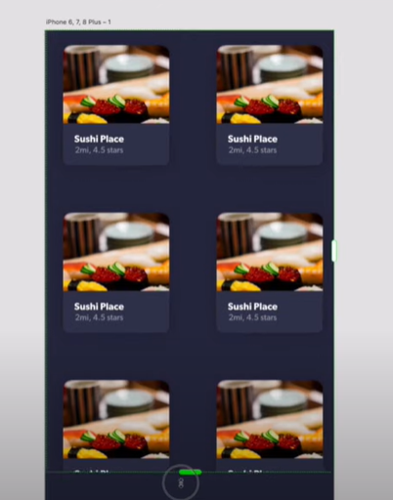

Figure 2: Copy of Design

As shown in **Figure 2**, the designer can easily drag the layout and create infinite copies of their design. And the design is automatically sorted into a grid.

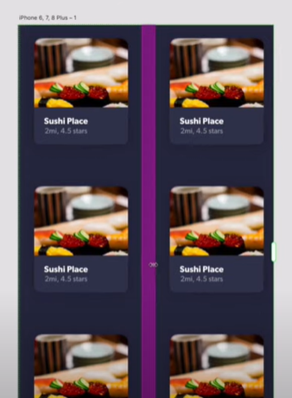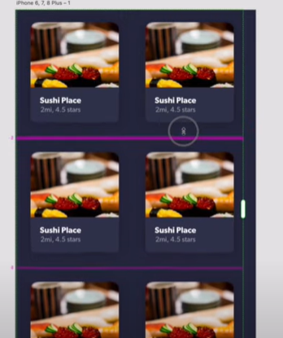\

Figure 3: Horizontal and Vertical Alignment

As shown in **Figure 3**, aligning the created copies vertically and horizontally can be done very easily thanks to adobe XD repeat grid feature.

### Components

A component is a reusable element that functions on two logics, main and instance. An instance is a duplicate of the main component**.** The modifications made to the main element are mirrored to all the instances, but the instances can be independently modified without reflecting the modification on the main.

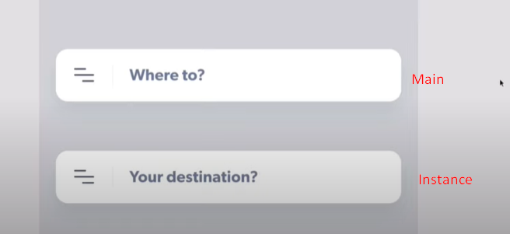

Figure 4: Main and Instance Components.

As shown in **Figure 4,** we have a main and an instance component. If we make the icon on the left in the main component bold, then automatically the icon in the instance will also become bold.

Moreover, all components have states in Adobe XD, which are basically variations of the component. So, for example, if we have a button, this button can have three states, idle, hovered, and clicked. And they all link back to the same main component but with different states.

## 2.2) React-Native

React-Native is a famous mobile application framework built on Javascript that allows you to build android and IOS apps simultaneously. React-Native was invented and implemented by Facebook as an open-source framework in 2015, and it became one of the most famous frameworks used for mobile application development. Before react-native, developers used to wrap their Javascript-based application with something called a “webview” to be able to deploy them as mobile apps to mobile devices. That worked, but it was still hard to a make a website give the native feel of a mobile application, the developers also had to write the code every time for each new system they wanted to deploy on. So at least twice for IOS and android [4].

And that’s how react native was born, the developers can change the code in one place, and then it is automatically compiled and shipped to both the app store and the play store, resolving the biggest headache and creating the era of “Learn once, use many” [5].

### React Native Under the Hood

React native works in a really special way, it allows the developers to work on apps by creating Javascript threads that understand Javascript code. This means it makes a bridge between the app and the platform that the application is targeting. This bridge takes advantage of the library and transforms the components hierarchy to mobile device views. For example, toggling a toggle would be translated into an event that Javascript can handle, after that, via the messages between native platforms and Javascript code, the react native bridges translate native events into something that react-native components can understand and make sense of [6].

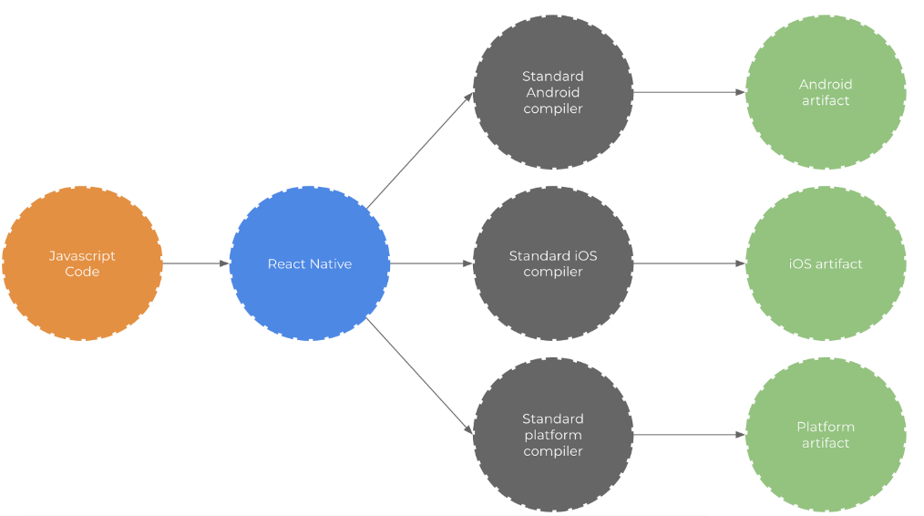

Figure 5: How React Native Works

As shown in **Figure 5,** the developer writes Javascript code, which is then (based on the platform) is converted accordingly via the bridge (the blue circle). For example, if we had a button, react native bridge will connect the button to the android button or IOS button based on the platform [7].

### Advantages of React Native

Here are some (and not all) of the advantages of react-native:

* **React native is community-driven:** Facebook made react native in 2013 actually, but made it officially open source in 2015. This allowed a flood of skilled and talented developers from around the world to join in and add to this already amazing library. This also created a bond between the react-native community and react-native itself, in return, this makes it really easy to find help online when using react-native.
* **Optimal code reuse and cost-saving:** in react native, you can use the same code for android, ios, and any other platform. Which are a huge time and cost saver for any developer/business.
* **Live reload:** If you had two screens, one has the code and the other has the emulator for your work. You can immediately see the changes you made to your code without the need to close and reopen the emulator. Which is such a beautiful thing.
* **Strong performance:** react native is made and tuned for mobile environments because it makes use of the GPU and not only the CPU.

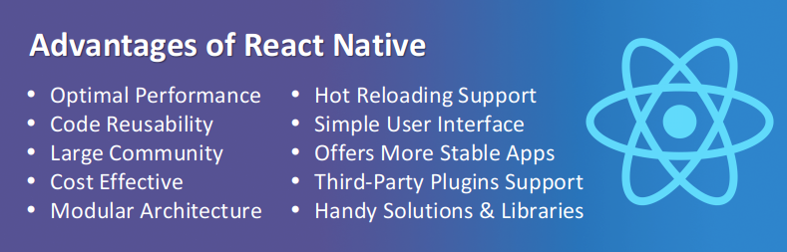

Figure 6: React Native Advantages

As shown in **Figure 6,** react-native has countless advantages, some of them are already mentioned above but more can be seen in the figure [8].

### Cons of React Native

It’s not all rainbows and sunshine in react native land, there are also some cons and they are as follows:

* **Hard to debug:** since it’s a cross-platform library, sometimes bugs can occur on one platform but not the other, which makes it hard to determine if it’s the result of the code or the platform itself.
* **Hard to determine UI:** transitions and animations can get quite tedious if the developer has a lot of them because he needs to be careful that these animations align with the standard for the platform.
* **Still immature:** react native is still new, which means that every update has some major changes usually. And sometimes, this makes it hard to adapt.

### Javascript Syntax Extension (JSX)

React native is written in JSX, it’s simply Javascript script functions that are sugar-coated to make it easier for the developer to use and read. It uses a syntax similar to HTML, with opening and closing tags, but at the end plain Javascript functions that are executed at runtime [9].

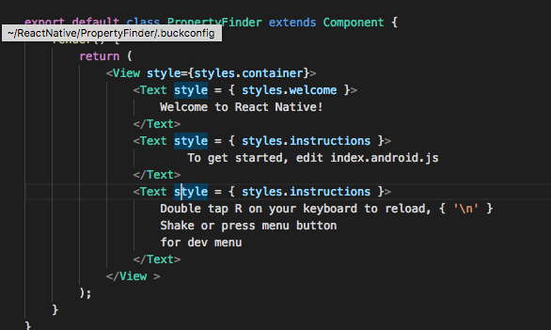

Figure 7: JSX Example

As shown in **Figure 7,** this is a simple example of the react-native syntax. **View and Text** are the JSX tags.

## 2.3) Node JS

A lot of big companies use Nodejs to build their applications, like LinkedIn, Netflix Uber, Trello, and many more. Even though the technology is still relatively new (released in 2009) it is bringing a lot of developers and corporate businesses in because of its amazing features. Additionally, any developer who is familiar with Javascript will not have a problem with picking it up.

NodeJS is an open-source, runtime environment for running Javascript code independent of the browser. Its use in the web is often to build backend services or application programming interfaces (APIs for short). Nodejs is perfect for implementing scalable, data concentrated, and instantaneous backend services that back up our application. Furthermore, the technology is non-thread blocking and it presents the event loop construct [10].

### Non-thread Blocking

This is what node is mostly famous for, non-thread blocking means that there are no worries of deadlocks because all processes are done asynchronously. Even though Javascript is single-threaded, Nodejs still manages to provide great performance for I/O operations with nearly no blockage.

### Event Loop

Node presents and utilizes an event loop; the event loop is what allows and enables nodes to perform non-blocking tasks (even though javascript is single-threaded) by delegating tasks to the system kernel when possible. And since modern-day kernels are multi-threaded, they can handle multiple tasks simultaneously without any issues.

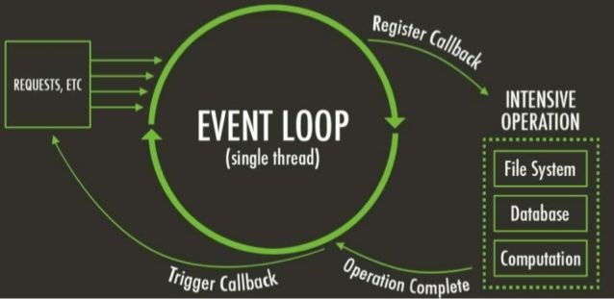

Figure 8: The Event Loop

As shown in **Figure 8,** the event loop can be looked at as an infinite loop. The **register callback** part is where the event loop delegates work to system kernels. And when the **operation is complete**, the system kernels give the event loop the result. Which then fires the **trigger callback** step, and this basically does any required operations to the returned data.

## 2.4) Typescript

Javascript became the known scripting language for the web over time, but the problem with current Javascript is that it’s not made for current, modern, large web applications. Why? Because it is really hard to scale an application that is made without any kind of type checking during development, which results in messy, huge bugs after deployment.

In comes typescript, to put it lightly and simply, it is a superset of Javascript that provides static types and is compiled to plain Javascript, so it can run in the browsers. Why do we need static types though? For many reasons, but some of them include avoiding null and undefined values that the developer won’t be aware of without the help of a compiler, giving the developer the ability to refactor the code more easily whilst being aware of any breaking changes, and finally, depending on external documentation or someone’s brain to memorize return values is no longer needed [11].

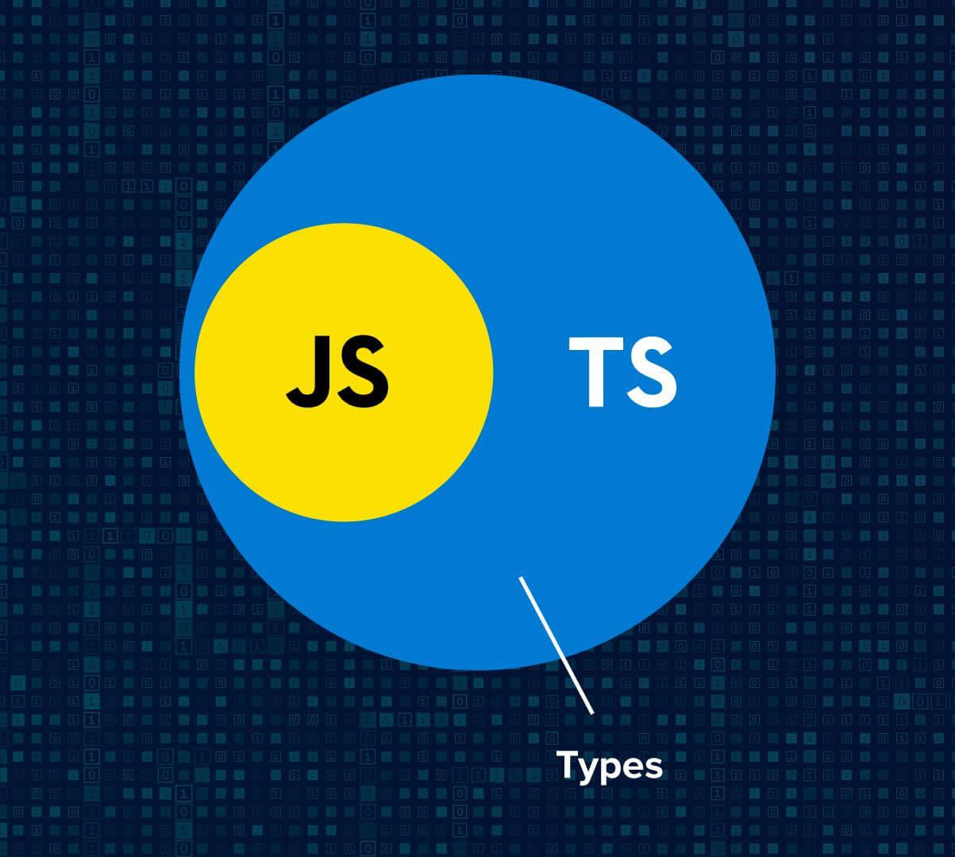

Figure 9: Vin Diagram of Typescript

As shown in **Figure 9,** all typescript does is add types to Javascript. Making it easy to develop and ensuring that fewer bugs arise after deployment.

## 2.5) MySQL

A database management system is a program that communicates with the end-user, software applications, and database to engulf and inspect data. The type of data stored in a database management system can be numbers, strings, dates, images, etc. MySQL is a relational database management system. It is powered by oracle, is open-source, works on many platforms, provides very good connectivity, is scalable, provides data migration, and many more features. It also uses a structure that allows the users of the database management system to identify and access data that has relation(s) with another piece of data in the database [12].



Figure 10: MySQL Logo

As shown in **Figure 10,** this is the MySQL logo. Fun fact, the dolphin represents the performance, power, and precision of MySQL, and its name is Sakila [13].

## 2.6) Amazon Web Services (AWS)

Amazon Web Services (AWS) is a cloud secure computing platform that provides scalable computing power, database, content storage, networking, and much more. It has a pay-as-you-go pricing model, this allows the developer to not pay for what they haven’t used. It was first introduced in 2002 to provide tools and services for developers, to enable them to use some amazon services in their websites. In 2006, its first service was introduced. And now, AWS provides over 250 web services that serve in multiple different domains [21].



Figure 11: AWS logo

As shown in **Figure 11,** this is the AWS logo.

### AWS Relational Database Service

The AWS Relational Database Service provides the users with a way to host their databases on the cloud. It also offers them the ability to monitor the connections, load on database, configurations, and many more options.

### Advantages

Some of the advantages of AWS are:

* **Security:** AWS provides security that is end-to-end.
* **Great user experience:** Because of the dashboard it provides
* **Flexible:** Allows users to select OS, language, database, and much more.
* **Easy to user:** Users can host applications fast and securely.
* **Scalable:** Depending on user requirements, applications can be scaled up or down.

## 2.7) Postman

Postman is a tool to interact and test web-based APIs. Postman helps with the process of sending requests and receiving responses. It is a tool that gives the user an interface for the server, so that he is able to test the functionality of the server with ease.



Figure 12: Postman logo

As shown in **Figure 12,** This is the Postman logo.

### API user interface

The API user interface is what Postman is all about. Simple giving the user a visualization of the API workings through a set of functionalities available in the application.

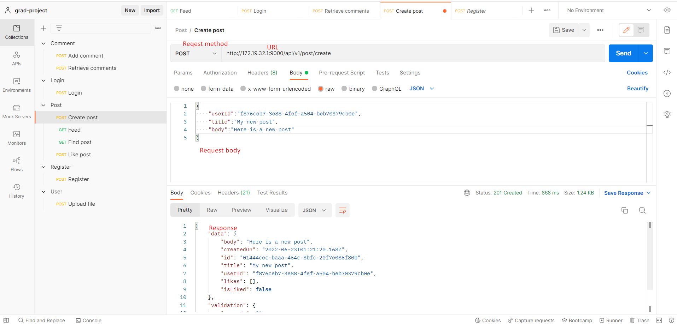

Figure 13: Postman UI

As shown in **Figure 13,** This is the main UI of Postman. At the top is the http method and URL of API, In the middle is the request body (because it is a POST request), and at the bottom is the response body which is in prettified JSON format.

## 2.8) Barcodes

Barcodes are found on any product that you see in any store. When a computer scans through a barcode, it is actually scanning through 95 evenly spaced columns. And checking to see if it reflects light or not. Since computers only understand one’s and zero’s, any columns that reflect no light are considered a one, and any columns that reflect light are considered a zero. When a computer reads a barcode, it yields out a 95-bit number, these bits are then grouped into 15 separate groups. 12 of these sections are used for the numbers that you see on the bottom of the barcode; the other 3 sections are used as guards. These guards let the computer know where the barcode starts and ends, and where the center of the barcode is.

### Barcode numbers

Each barcode in the world resembles a number when its scanned, these numbers on each barcode have meaning. First number tells us which category the barcode belongs to. The next set of six numbers resemble who the manufacturer of the product is. The last set of six numbers resemble what the product is. And finally, first three numbers combined resemble the country of manufacture [14].

### Types of Barcodes

1. One-dimensional barcode: usually contains information like product type, size, and color
2. Two-dimensional barcode: is more complex than the one-dimensional type, and can contain more info, like text, inventory levels, and even an image of the product!

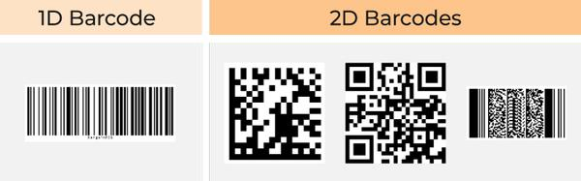

Figure 14: Types of Barcodes

As shown in **Figure 14,** 2D barcodes are more complex with shapes, but we only care about 1D barcodes. Because most products have 1D barcodes

Chapter 3: Related Work

The More we know about the product, the better product we can deliver. In this chapter, to know the product better, we researched the product and looked at related content. This chapter can be split into two sections, sections 3.1 and 3.2.

Section 3.1 talks about three applications similar to ours, and sheds light on their pros and cons, in addition to a summary of all the features, which will show how they differ from our app. In section 3.2, we research and summarize three papers related to our app, which will help us know the app better.

## 3.1) Similar apps

### 3.1.1) Buycott – Barcode Scanner Vote

The application was released in 2013 with more than one million downloads on google play. It helps its users to make changes and get unbiased information about the products by using a barcode scanner. Features in the application include:

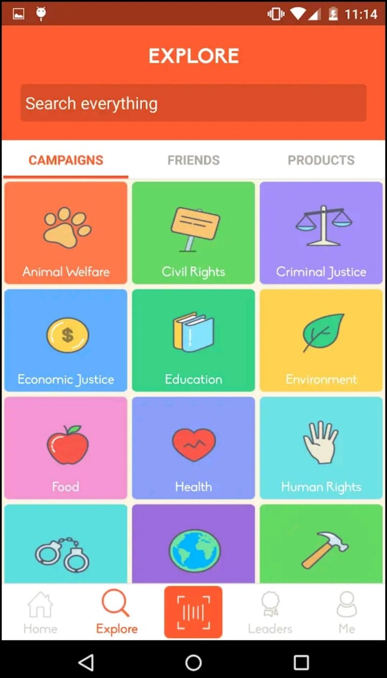

Figure 15: Explore and Join Campaigns

As shown in **Figure 15,** the application allows you to look up and interact with multiple categories. These categories are static and don’t change over time, which restricts the user experience in the long term.

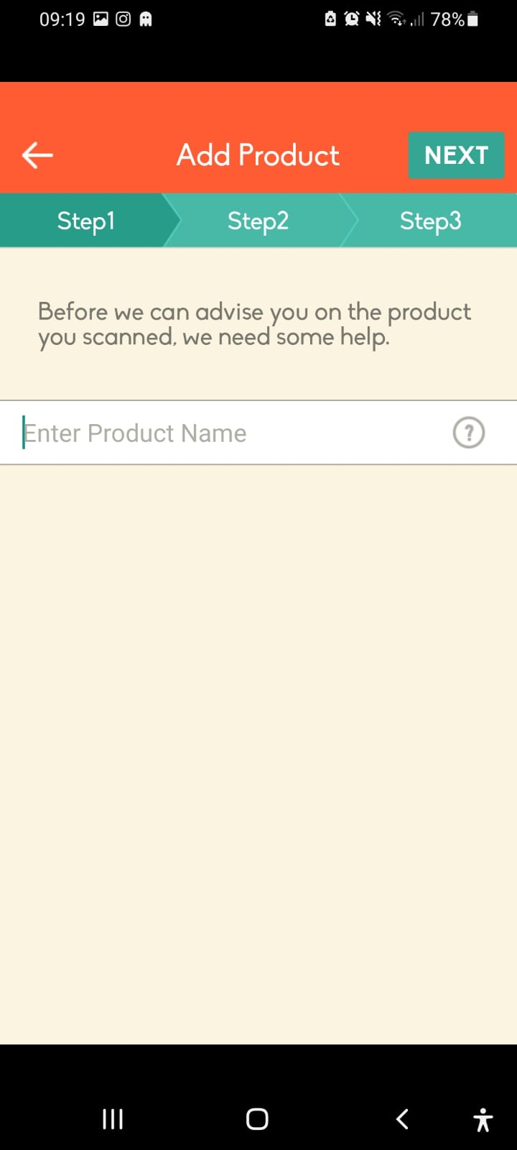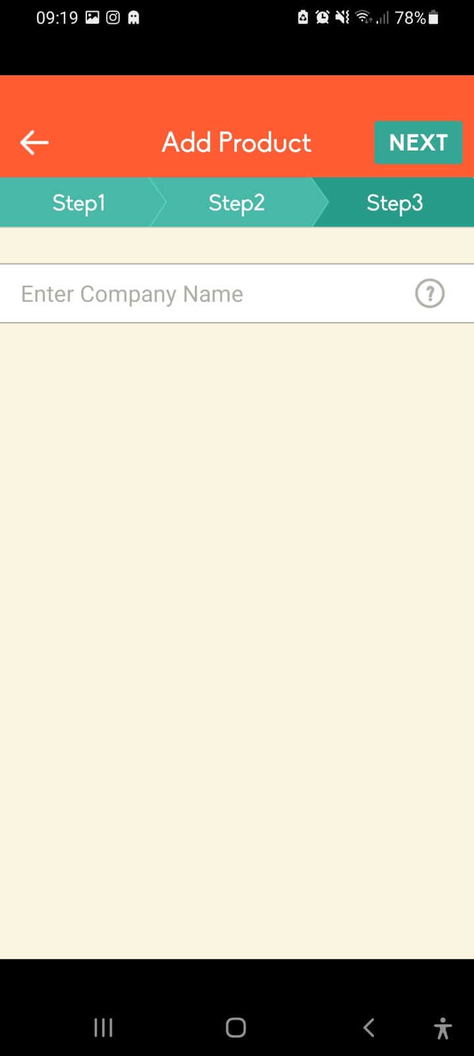

Figure 16: Suggest a Product

As shown in **Figure 16,** This is a three-step process that allows the user to firstly enter a product name, enter the product’s picture, and finally enter the parent company of the product. So that the maintainers of the app can add the product to their database.

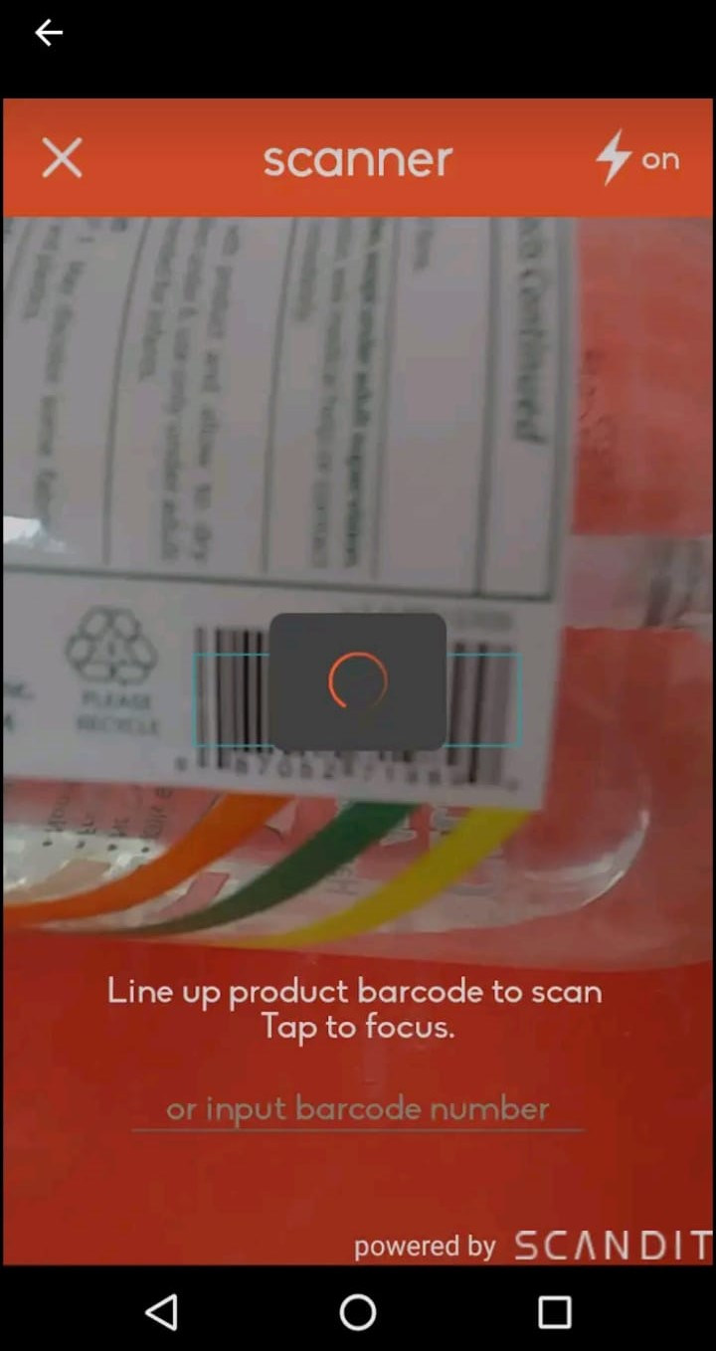

Figure 17: Scanning a Product

As shown in **Figure 17,** the user has the ability to scan barcodes and get information about the product. The application also suggests alternatives for the product (sometimes), shows what campaigns/movements conflict with the product, and it also shows information about the company that made the product

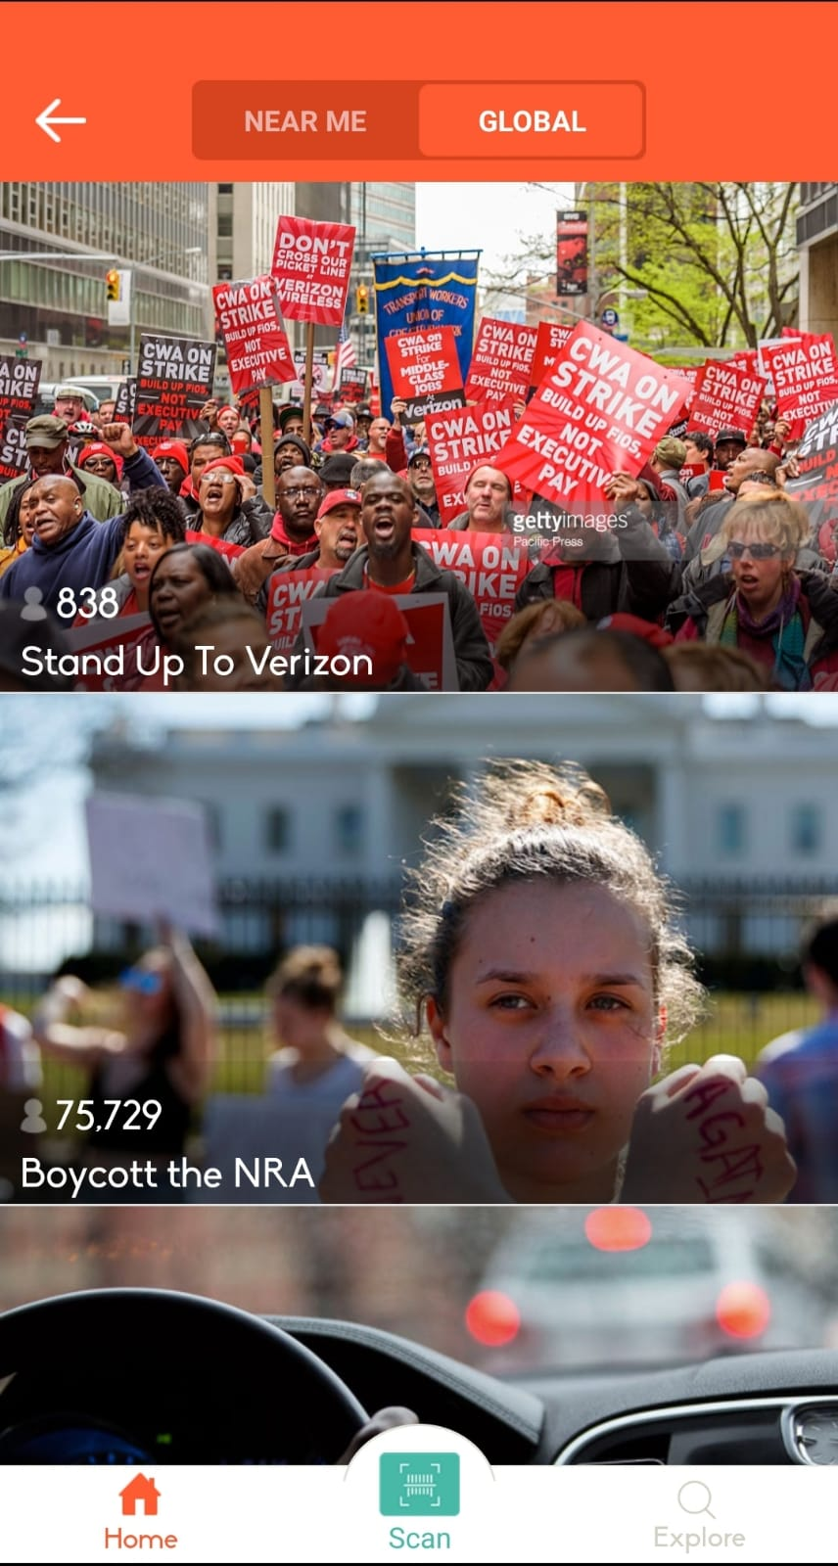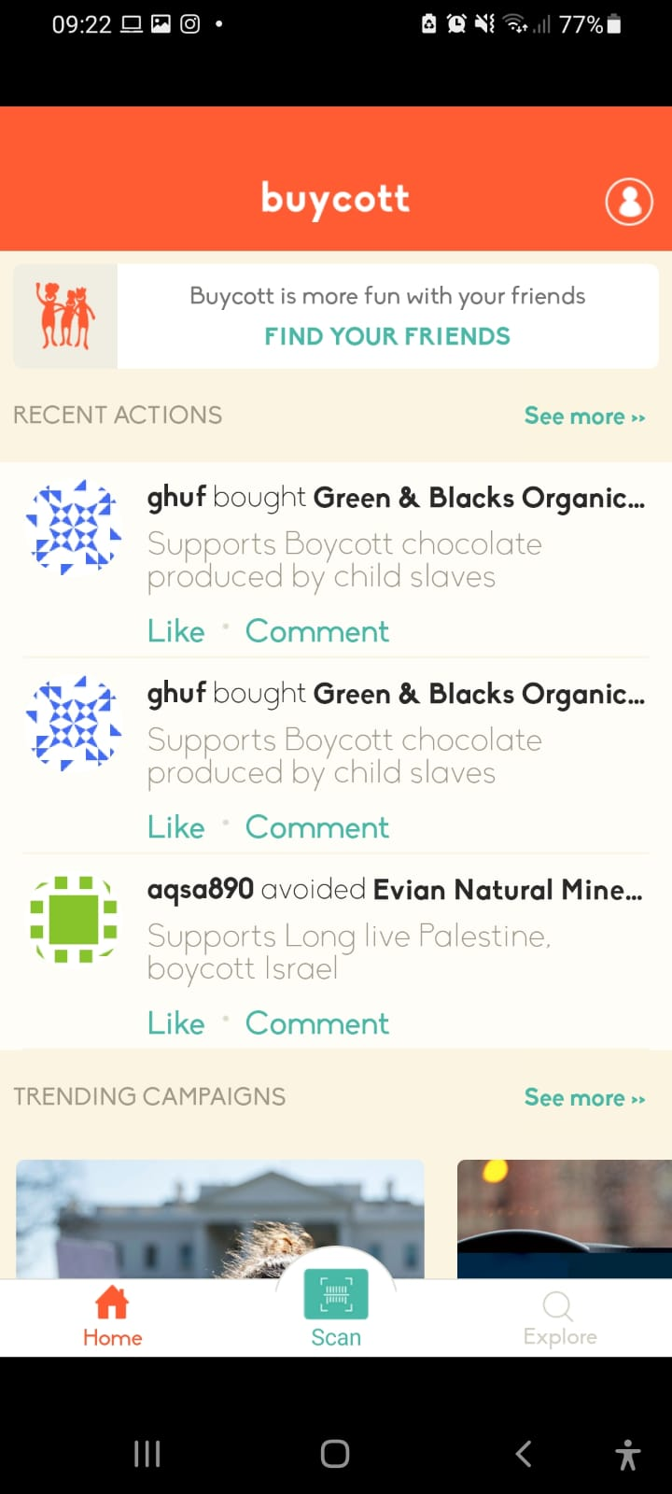

Figure 18 Trending Campaigns and Recent Actions

As shown in **Figure 18,** the application shows some trending campaigns, it also shows recent actions/campaigns near the user’s location.

### Pros of Buycott

There is a lot of pros and good things about this application, like the fact that it is the first of its kind, it also has had a very large audience in the past, and finally, the application has a very large database that contains a lot of products and their parent companies.

### Cons of Buycott

Buycott is not a perfect application, it is full of flaws, no updates have been pushed to the application since 2016, their API costs money for developers to use, it is a social media app in disguise, and last but not least, it is full of errors and unexpected crashes.

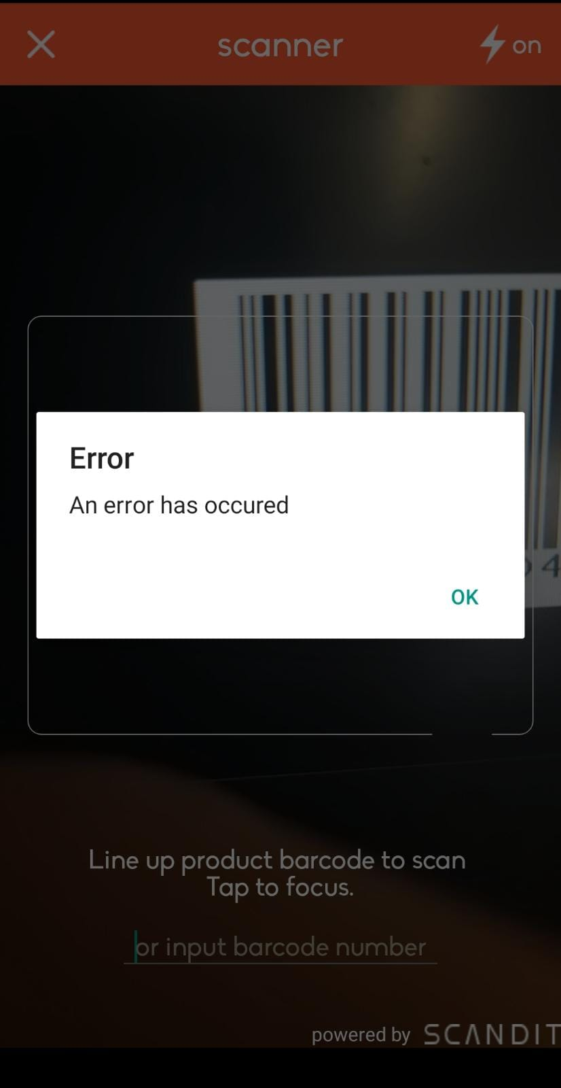

Figure 19: Slow Loading and Errors

As shown in **Figure 19,** the application most of the time crashes whilst trying to scan barcodes and it takes a lot of time to load campaigns and categories related to these campaigns.

### Differences

These are some of the differences between our app and buycott:

* Our app will have constant updates
* It will not have as many errors
* Our application will be built on the community for the community

### 3.1.2) QR and Barcode scanner

QR & Barcode Scanner is a mobile application that allows the user to scan and open QR codes, in addition to scanning barcodes. The application is simple and goes straight to the point, what it does is scan barcodes and QR codes. That’s it.

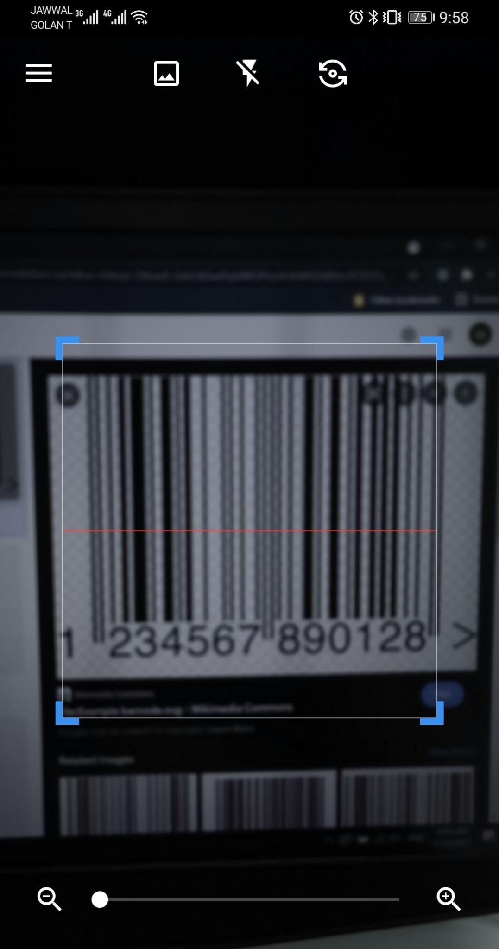

Figure 20: Main Page

As shown in **Figure 20**, the app starts with its main page, the main page contains the camera for scanning, it also contains three icons on the top, two of which are used to flip the camera and use the flash, and one to save the scanned image to the phone. The main page also contains an icon used to open the sidebar, which contains the rest of the app’s features, such as accessing the scans history and the QR creation feature.

### Features

* **Scanning QR codes:** the app uses the phone’s camera to locate and scan QR codes, after the scanning was completed successfully, it moves the user to a new page containing the QR code’s link, in addition to an icon for opening it, and icon to share it, and an icon to copy the link.
* **Scanning barcodes:** the app uses the phone’s camera to locate and scan barcodes, after the scanning was completed successfully, it moves the user to a new page containing the barcode number, in addition to an icon to web search the barcode, and icon to share it, and icon to copy it, and an icon that takes you to Amazon and searches for the product with the matching barcode for the user to buy if found.
* **A history with previous scans:** the app will have a page containing a list of all previous scans and their info.
* **Create a QR:** the app will allow the user to create a new QR code with various info, such as a URL, contact, email, SMS, location, and much more.
* **A favorite section:** the app will have a page contacting the favorite scans which were saved by the user.

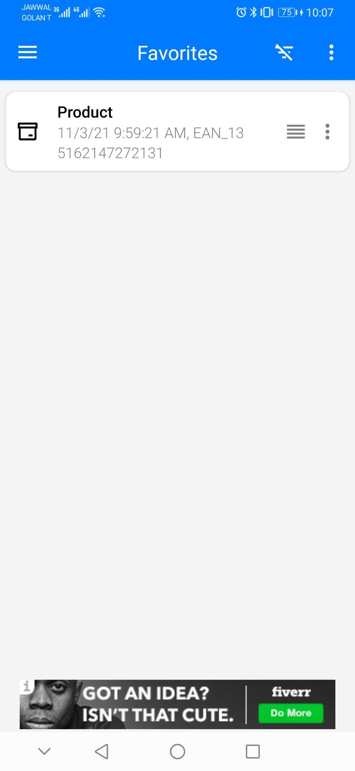

Figure 21: Favorite Scans

As shown in **Figure 21,** the application gives the user the ability to save favorite scans that the user has done in the past.

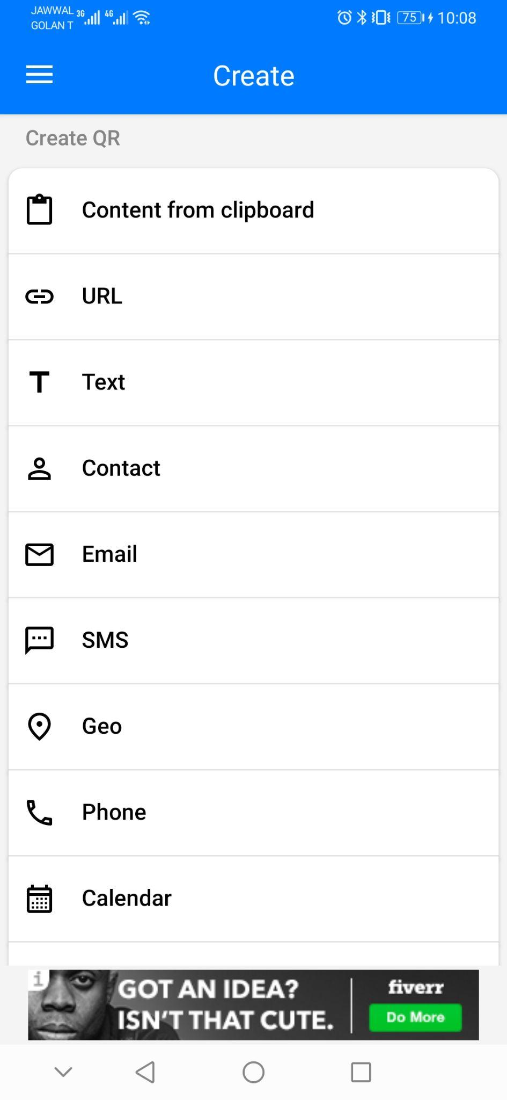

Figure 22: Create Code

As shown in **Figure 22,** the application gives the user the ability to create their own QR codes for their own personal usage.

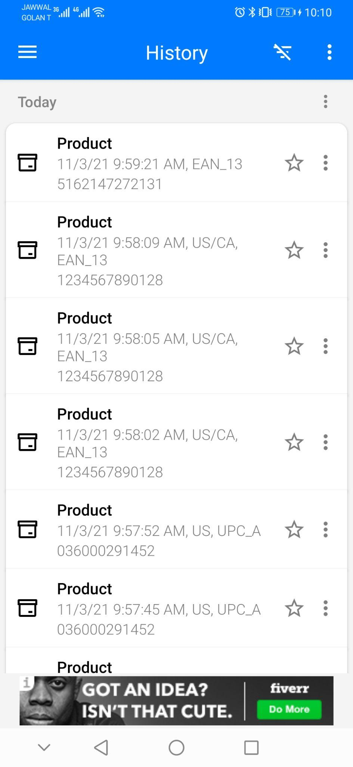

Figure 23: History View

As shown in **Figure 23,** the user can view their past scans via the history view.

### Differences

Our app differs from the QR & Barcode Scanner in different areas summarized below:

* Instead of only showing the barcode number, our app will have the ability to fetch the products info and display them.
* Our app will have a community that will help in adding info to the barcode database.
* Our app will have the ability to load a barcode picture from the phone’s local storage and scan it.

### 3.1.3) Facebook

Facebook is a social networking website that was founded and created by Mark Zuckerberg to connect with his college friends in 2004. By 2006, Facebook became a social networking platform for anyone above the age of thirteen. It gives the users the ability to create accounts and sign into them, then start viewing posts from all over the world. It also allows users to join groups to talk, chat, and view posts from people. Users can also share their thoughts and ideas via stories, which are temporary posts that are visible for twenty-four hours only. Finally, Facebook allows advertisers to pay and put advertisements on Facebook, and it integrates that with the data collection it does about users to show them specific advertisements about things they want.

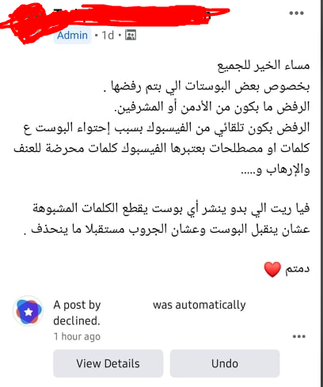

Figure 24: Screenshot of a Post

As shown in **Figure 24,** a post was taken from Facebook group. Coincidentally, the owner of the post is complaining/warning other members of posting any controversial topics in their posts, because Facebook is striking them down.

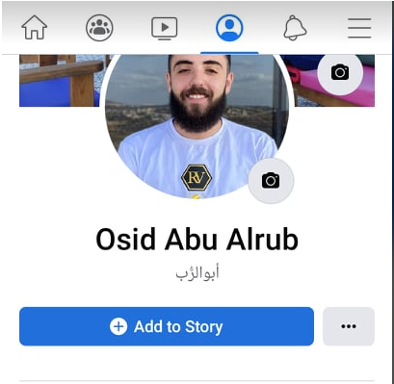

Figure 25: Screenshot of a Facebook Profile

As shown in **Figure 25,** Facebook gives the user the ability to create their own profile and visit other people’s profiles. A profile includes a profile picture plus some possible functionalities for the owner of the account. In this case, these functionalities are adding a story (which is a picture or a video that is available for 24 hours only) or changing the profile picture.



Figure 26: Screenshot of a Group Post

As shown in **Figure 26,** a post that exists on a private programming group, the post here is mainly educational. It is also posted in a group that includes programmers from all over the world.

### Differences

Even though Facebook is really old, it still has issues (other than silencing voices). Some problems include the following:

* **Privacy:** Teens can often forget that what they post on Facebook is public, and unless their personal profiles are set to hidden/private, any user can enter and view the information of their profiles. Usually, teens post a lot of personal information online like images, videos, or telephone numbers
* **Predators:** A lot of times predators and other bad people target young people on Facebook. Due to the fact that its nature pushes adding and meeting new people online, which leaves a lot of young people vulnerable.
* **Cyberbullying:** Facebook provides bullies with a new way and method to bully people online. They can now send repeated bad messages to people and hurt their feelings, and sometimes lead these people (who are bullied) to become depressed and have suicidal thoughts.

### 3.1.4) Summary of features

As shown, the apps above provide some smart features like the ability to socialize on Facebook, the ability to read QR codes from the QR scanning app, and the ability to create campaigns in Buycott. But they also lack some primary features like:

* Privacy
* Ability to express and share opinions freely
* Listening to feedback
* Focused action
* Constant updates
* No bugs
* Responsive and modern
* Built on community
* Image processing

All of the above features and more are going to be included in our application.

The following table summarizes the differences between our app and the mentioned apps:

Table 1: Feature comparisons

|  |  |  |  |  |
| --- | --- | --- | --- | --- |
|  | Facebook | QR & Barcode | Buycott | Our App |
| Ability to fully express opinions | No | No | Yes | Yes |
| Privacy | No | No | No | Yes |
| Used to socialize and learn | Yes | No | No | Yes |
| QR scanning | No | Yes | Yes | Yes |
| Scanning from local storage | No | No | No | Yes |
| Constant Updates | Yes | No | No | Yes |
| Listen To Feedback | No | No | No | Yes |
| Built on the community for the community | No | No | No | Yes |

## 3.2) Literature Review

### 3.2.1) Does boycotting actually work?

### What is boycotting?

Whenever an employee or a consumer finds themselves disadvantaged negotiating against a higher company or person, usually the best choice of action is to boycott. Boycotting is when a person or a group decides to refuse to engage in all transactions involving products of a target company [15].

Boycotting is a non-violent, voluntary, and intentional way that involves refusing to deal with a certain product or target, meaning that the boycotters rely solely on moral persuasion.

### Outcomes of boycotting

Boycotts grow more popular by the second, as social media has made it easier to share and participate in boycott activities. A recent survey that surveyed a little over a thousand people showed that 38% of the people are currently boycotting something [16], but do they really work? “With a few exceptions, most threats to boycott do not impact the cash register, they are, however, a powerful means to pressure companies to take action”, said the vice president of Cone Communications.

To see whether boycotting actually works, we can take the Nestle boycott as an example, the boycott started in the 1970 and 80 when the company was accused of aggressive marketing of breast milk substitutes, which when mixed with non-suitable dirty water in poor countries, would not be good for consumption.

The boycott joined a lot of people and has been on-again-off since then, and although there were some claims that there were similar practices, the boycott resulted in much stricter legislations of how the company operates. Now whether that can be considered as a success depends purely on the motivation of the people participating, if the reason behind the boycott was to crush and damage the company financially, then clearly it didn’t work, but if the reason was to hold the company accountable of their actions, and spread the word, then it was a success.

### Successful boycotts

- 2021 - July

Ben & Jerry’s, one of the most successful ice cream brands, has stopped selling its product in all illegal settlements. The boycott was done by Palestinian human rights activists nearly 10 years ago. The company shared “We believe it is inconsistent with our values for Ben & Jerry’s ice cream to be sold in the Occupied Palestinian Territory”, said Ben & Jerry’s establishment [17].

- 2018 - September

Burberry, an iconic British luxury brand, has stopped using fur and angora, after a long-running campaign started by PETA. The campaign has been running for over a decade and methods such as dozens of protests outside Burberry stores and sending thousands of emails [18].

### Conclusion

In conclusion, boycotts do not, on average, harm the target financially, but that doesn’t necessarily mean that they’re useless, as we’ve seen several examples of successful boycotts that held companies accountable for their actions.

### 3.2.2) What is the purpose of using Facebook?

Facebook has the poke feature, which allows the users to offer opening greetings to other Facebook users, and provides room for meeting new people. As for Facebook usage, among the Facebook users, Hargittai noted that the usage of Facebook differs depending on the user's ethnicity, gender, race, and upbringing. Also, women use it more than men. Moreover, Mexican users are less likely to use Facebook than White people. And for users from Italy, they rated groups and games as the most important features in Facebook. But for Greek, these features were less important. And finally, United Kingdom users rated groups as the most important thing in Facebook [19].

Studies also showed that extroverts are more likely to use Facebook as a socializing tool, but introverts tend to use Facebook for other purposes. Like only viewing posts (not interacting with them) and using it to get up to date with the news around the world. Also, users with more open-mindedness are more likely to experience a lot of the personal information section features than users with lower levels of open-mindedness to experience.

Finally, people who had more active friends on Facebook seemed to have higher self-worth and self-esteem. In contrast to people who had inactive/no friends on Facebook, who showed a lack of self-confidence and self-worth.

### 3.2.3) Why do people participate in boycotts

The researchers collected data by an online petition posted on a virtual community and they collected data of 50,000 consumers that signed to participate in the boycott of Canadian Seafood. The following table shows the stated boycott motivations in a random sample of 1200 boycott pledges [20].

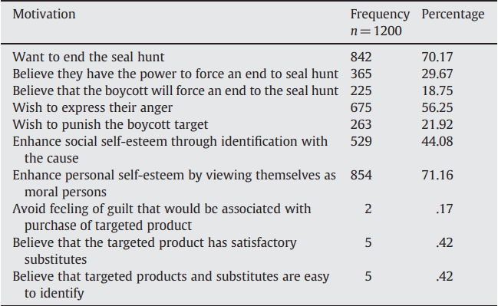

Figure 27: Boycott Motivations

As shown in **Figure 27,** the results of the research show that most of the consumers participating in the boycott do so because they want the bad policies and behaviors to stop. A high number of participants think that it is their responsibility to use their materialistic votes to make the change. Also, about a fifth of the participants have no doubts that the boycott will enforce the entity that’s being boycotted to change its conduct.

The results also show that more than half of the participants are motivated by their anger. A majority of the participants are motivated to participate because they want to see themselves as moral individuals. It also shows the participants are not motivated by feelings of guilt.

# 

# Chapter 4: System Analysis

This chapter presents the analysis model for the mobile app. It will include a use case diagram, sequence diagram, user and system requirements, and some other diagrams.

The diagrams are needed to showcase and simplify the process that the application is built upon, and the user-system requirements are needed to clarify what are the features exactly and how they are going to be used with details.

## 4.1) Use case diagram

The user's actions with the system represented as an illustrative portrayal/depiction, known as a use-case diagram. It also shows system actors, which are the various kinds of users that the application has.

The use case diagram below shows the most important operations that can be done by a user. It also shows all the actors that the system has, which are User, Admin, Campaign Manager, Location Services, and Social Media Services.

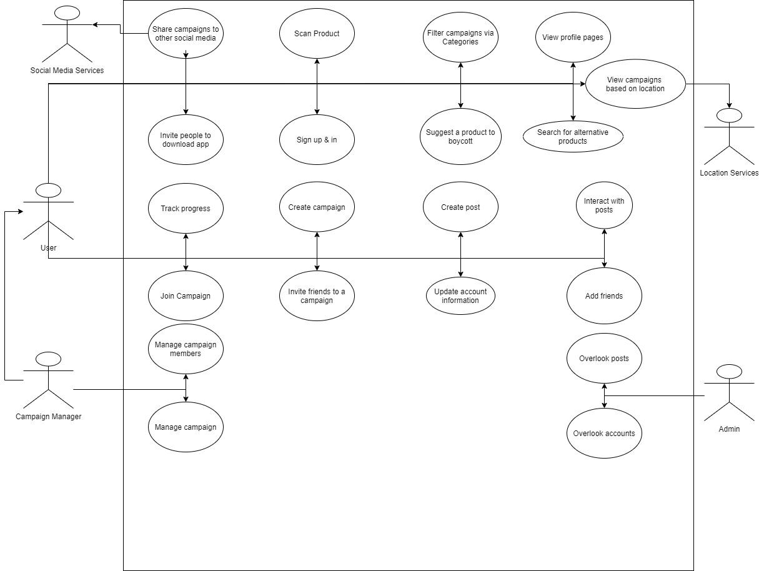

Figure 28: Use Case Diagram [1]

## 4.2) User-system requirements

user needs, also known as user requirements, represents how the user interacts with the system. For example, what actions the users must be able to do when navigating the system. On the other hand, System requirements are the core ingredient and factor that the developers use to implement the system. These are the typical must and shall sentences that illustrate what the system must do and shall do.

Table 2: User Requirements

|  |  |
| --- | --- |
|  | **Requirement** |
| **1** | **The user creates an account or logs in if he has an account** |
| **2** | **The user scans a product’s barcode** |
| **3** | **The user has the ability to share campaigns to other social media apps** |
| **4** | **The user can create campaigns** |
| **5** | **The user can join campaigns** |
| **6** | **The user should have the ability to search and filter campaigns based on categories** |

**UR1 The user creates an account or logs in if he has an account.**

**SR1-1** User opens the application and clicks register

**SR1-2** User fills required information (username, email, password, confirmation

password, gender). Username and email must be:

1. Unique

password must be:

1. At least 5 characters long
2. Contain one number
3. Contain one uppercase character.

**SR1-3** user clicks create account, one of the following can happen

1. User creates an account successfully, and he is logged into the system with the created account
2. Email or username is already taken, in that case, we inform the user and ask him if the email/username for the already existing account belongs to him, if yes, we direct him to the login page

**UR2 The user scans a product’s barcode**

**SR2-1** The user opens the barcode scanner in the application and points the camera at the barcode

**SR2-2** Barcode should be scanned within 5 to 10 seconds max

**SR2-3** If the product is recognized, then the user is redirected to a new page with more details about the product. The page should include

1. Name of product
2. Details about the product
3. Number of campaigns that the product aligns with
4. Number of campaigns that the product has a conflict with
5. Closest place that sells the product

**SR2-4** If the product is not found, the user is redirected to a page where he can add the name of the product, where he found it, and add a brief description. Then submit it.

**SR2-5** If the user submits the form successfully, an email will be sent to him thanking him for his contributions. He is also redirected to the barcode scanner page/view

1. If the user tries to close the page without submitting the form, a prompt will show asking him if he is sure of his decision
   1. If yes => the user is taken back to the barcode scanner
   2. If no => user stays in the form

**UR3 The user has the ability to share campaigns to other social media apps**

**SR3-1** Campaign homepage will have an arrow to share the campaign

**SR3-2** When the user clicks on the arrow, a modal will slide from below and it gives the user multiple social media options to share to

**SR3-3** When the user chooses a social media app, the user will be redirected to that app with a text template that is ready to just be posted/shared.

**SR3-4** If the user backs out (AKA doesn’t choose an app), then the modal just closes.

**UR4 The user can create campaigns**

**SR4-1** User is at the main screen and clicks “create campaign button”, and he is directed to create campaign form.

**SR4-2** The form includes the following required fields:

1. Name of the campaign
2. Categories that this campaign belongs to (at least 2)
3. Description of campaign
4. Who can join the campaign:
   1. Anyone
   2. Friends and friends of friends
   3. Friends only
   4. No one
5. Is the campaign invite-only?

The form also includes the following optional fields:

1. Invite friends’ checkbox
   1. If it's checked, upon creation, a notification will be sent to friends of this user telling them to join the campaign if they want to.

The form will also have three buttons:

1. Create a campaign button
2. Clear all fields button
3. “X” icon in the top right corner

**SR4-3** When the user clicks “create campaign” the campaign will be created and the user will be taken to the homepage of the campaign

**SR4-4** If the user didn’t click the “create campaign” button and instead decides to back out, the data he entered will be cached so that he can continue later.

**UR5 The user can join campaigns**

**SR5-1** For public campaigns, users can find them on the homepage or via invite by friends

**SR5-2** When the user clicks on a campaign to view it, he will see an overview of the campaign. The overview will contain:

1. Title
2. Number of members
3. Is it trending?
   1. If the number of members joining in the past week is more than 50% of the number of current members AND the number of members is more than 1000 => then the campaign is trending.
   2. How many people joined in the last week compared to other campaigns (most successful 3)
4. Categories
5. View more button
6. Join button

**SR5-3** If the user clicks the join button, then he will be a member of the campaign successfully.

**SR5-4** If the user clicks the “View More” button, he will be directed to the homepage of the campaign, where he can learn more about the campaign and see posts.

**SR5-5** He will have a join button at the bottom of the screen so he can join the campaign if he likes it.

**SR5-6** If the user clicks the join button, the process in **SR5-3** steps.

**UR6 The user should have the ability to search and filter campaigns based on categories**

**SR6-1** The user will have an icon at the top of his screen, if he clicks on it, an input field will appear

**SR6-2** The input field will have a mini dropdown on the left, when the dropdown is clicked it will show 2 options for filtering:

1. By Name
2. By Category

**SR6-3** If the user chooses to filter by name, then the text he writes in the input field will result in a campaign that contains the entered text.

**SR6-4** If the user chooses to filter by a category, then the campaigns he will get as a result of filtering must contain the category the user filtered for.

**SR6-5** If no campaigns match the value the user is searching for, a text “No Campaigns That Match Your Search” exists. Also, an option for him to create a campaign that matches his search will be given to him.

## 4.3) Class Diagram

This diagram will be representing the main classes of which the application consists of, it shows each class and its relationship to the other classes, in addition to some of the attributes and methods it handles. So, in conclusion, class diagrams include class names, class attributes, and class methods. And its main purpose is to show and simplify the roles and relations between a group of objects in the system.

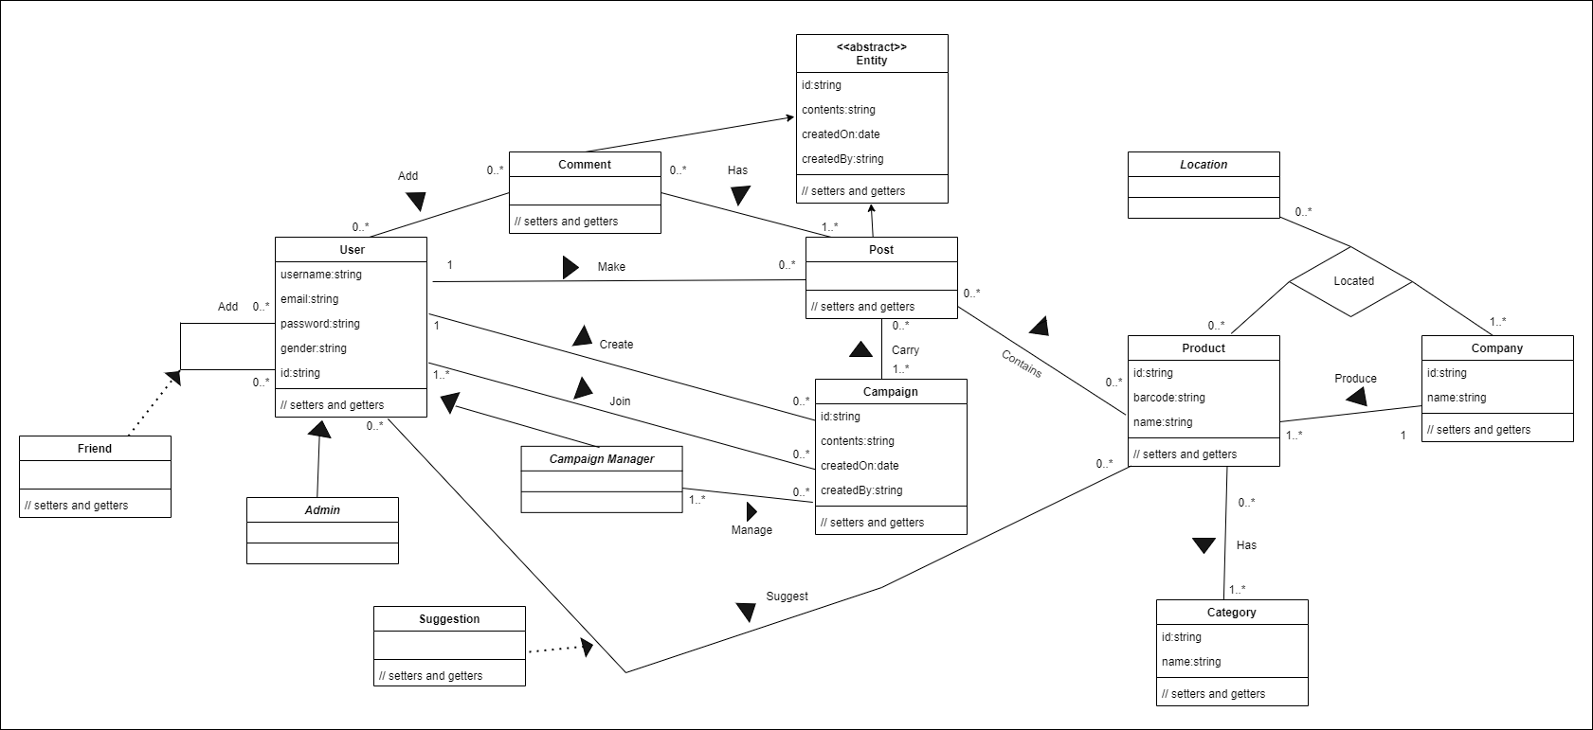

Figure 29: Class Diagram [2]

## 4.4) Activity Diagrams

Activity diagrams are used to describe a process in the system. This process can span over multiple use cases, which means activity diagrams have a one-to-many relationship with the written use cases. It is important due to the fact that an activity diagram helps the programmers and developers to comprehend and see the workings of the application from a high-level point of view. Furthermore, it helps them to find out limitations, conditions, and the corresponding events.

### 4.4.1) Creating account activity

This diagram shows how the account can be created by the user, and how the app behaves based on the user's actions. The activity goes as the following:

User fills the info and clicks on the create account button, the app then checks if it exists, if it does, it redirects the user to the login page then validates it, if it's not, it validates it, then takes it to the login page.

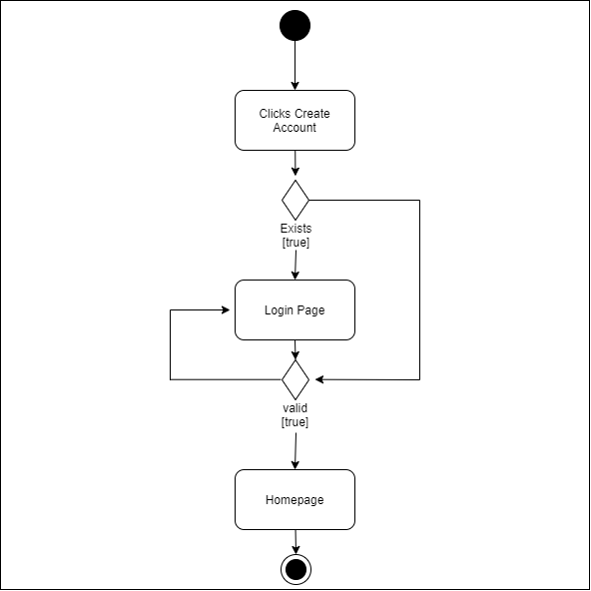

Figure 30: Create Account Activity Diagram [3]

### 4.4.2) scanning the product activity

This diagram shows how the product scanning works, and how the app behaves depending on the output information. The activity goes as the following:

The users scan a barcode using the built-in camera, if the product exists in the app’s database, the app redirects the user to the products page, if the product was not found in the database, the app will direct the user to the product suggestion page, where he can register the product in the database, the re-directs the user to the home page.

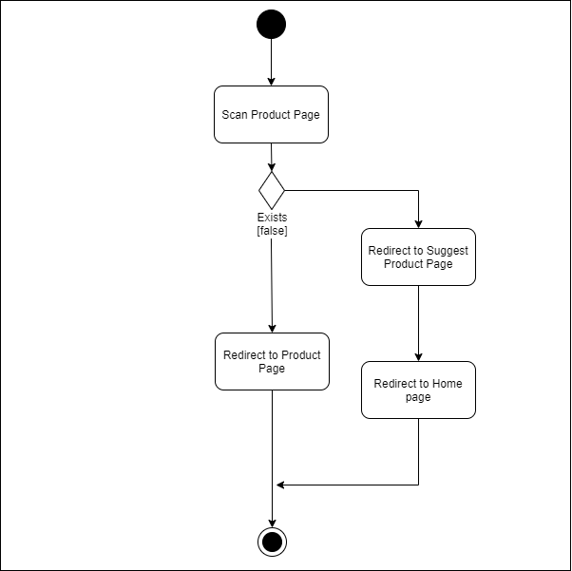

Figure 31: Scan Product Activity Diagram [4]

## 4.5) Sequence Diagrams

Sequence Diagrams show how certain tasks are performed between users and the system, these tasks can be repetitive, simple, or complex. The goal is to depict the use case in a visual format. Sequence diagrams help the developer understand use cases and how they operate. The Model-View-Controller pattern was followed in creating the sequence diagrams. This pattern is used to split up application concerns.

### 4.5.1) Scanning a product

This sequence diagram shows how the users interact with the app to scan a product using the app’s built-in scanner.

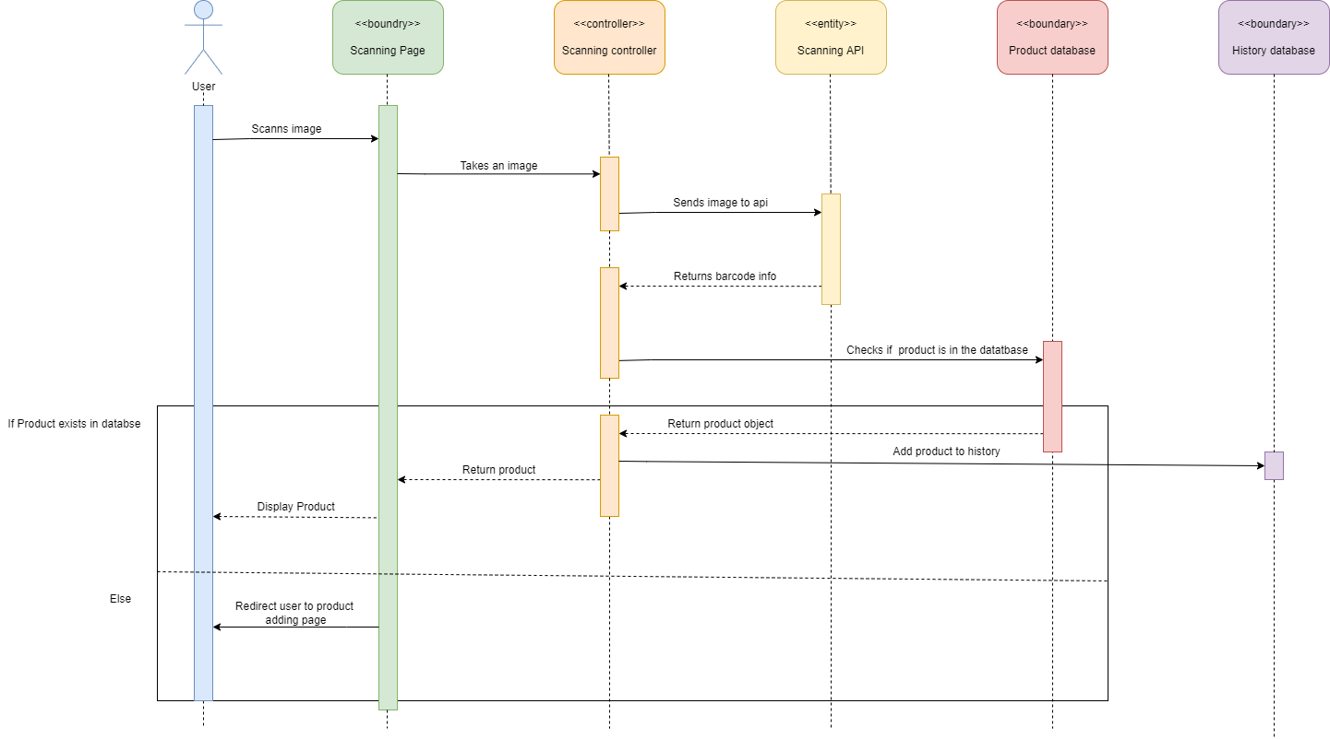

Figure 32: Scanning a Product

### 4.5.2) Filtering

This sequence diagram shows how the users interact with the app to filter the campaigns and how it works.

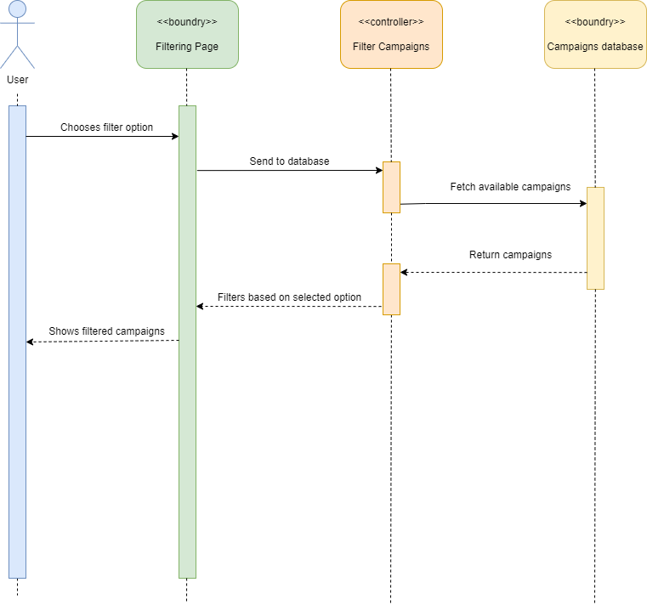

Figure 33: Filtering Campaigns

## 4.6) Software architecture

The application architecture diagram is a high-level diagram that shows the application basic structure, it consists of the following:

* **Client-side application:** the frontend layer to which the user has access to see and use. It consists of the following layers:
  1. **UI layer** is the components the user sees and interacts with.
  2. **Service access layer:** handles the requests and calls to the server-side.
  3. **Application logic layer:** controls the data fetched from the server and vice-versa, and performs all the operations on that data.
* **The server-side application:** this part of the application happens behind the scene on the server and users don’t have access to, and it consists of the following layers:
  1. **REST APIs:** the interface of the server-side of the application to the service access layer in the client-side, and it is the only communication between the client-side and the server-side and the database.
  2. **Data access layer:** holds the connection and configuration to connect to the database.
  3. **Database:** where all the data of the users and campaigns and other data is stored.

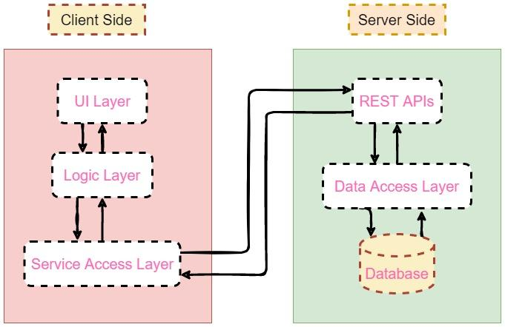

Figure 34: Software Architecture

# Chapter 5: System Design

This chapter is all about user interfaces. It will showcase some of the user interfaces that the app will have. All of the user interfaces here were made with Adobe XD, we were able to leverage repetition grids and components features that are in Adobe XD to make the process of creating the user interfaces much easier. Also, the export feature allowed us to extract the create interfaces with ease and high quality.

## 5.1) User Interface:

**Note that all following figures show view for both Android & IOS. On the right are Android mockups. On the left are IOS mockups.**

### 5.1.1) Sign in Interface

The sign-in interface is where the user will be able to log into the app using his private username and password, the interface consists of two text fields, one for the email, and the other for the password, there’s also a sign-up button at the bottom in case the user has not signed up.

|  |  |
| --- | --- |
| No description available. | No description available. |

Figure 35: Sign in Interface

### 5.1.2) Sign Up Interface

The sign-up interface is where the user usually creates an account in the app, the interface consists of 4 text fields, a full name, an email, a password, and a confirmation for the password.

|  |  |
| --- | --- |
| No description available. | No description available. |

Figure 36: Sign Up Interface

### 

### 5.1.3) Feed Interface

In the feed interface, the user is presented with a continuous collection of a smaller version of a post, which works similar to a recycler view, the interface consists of the feed header, the post, and the reaction buttons for each post.

|  |  |
| --- | --- |
| No description available. | No description available. |

Figure 37: Feed Interface

### 5.1.4) Sidebar Interface

The sidebar interface allows the user to access different features and interfaces more easily, it consists of the user’s info at the top, followed by home, scan, search, messages, and settings buttons

|  |  |
| --- | --- |
| No description available. | No description available. |

Figure 38: Sidebar Interface

### 5.1.5) Post Interface

The post interface is where the user can share his opinions, it consists of the post’s header, followed by the body of the post, in addition to the issue date and the number of participants following the campaign

|  |  |
| --- | --- |
|  |  |

Figure 39: Post Interface

### 5.1.6) Search Interface

In the search interface, the user can search for campaigns with multiple filters that can be applied via a dropdown.

|  |  |
| --- | --- |
| No description available. | No description available. |

Figure 40: Search by Filter

# Chapter 6: Implementation & Testing

This chapter will mainly focus on how the application works via its implementation. It will also showcase the testing process that the application went through to ensure its working smoothly. The testing section is split into two parts, manual testing and API testing.

## 6.1) Implementation

The main idea of the application is to allow the users to make a change in the world via boycotting. This requires them to make posts and campaigns. But to do such a thing, they need to register and create an account first. They need to provide an email, password, first name, last name, phone number, and a little bio about themselves.

|  |  |
| --- | --- |
| No description available. | No description available. |

Figure 41:Signup interface

As shown in **Figure 41,** If the user has an account, he/she can just click on “Login here” button and navigate to login view. Where they can login using their credentials.

|  |  |
| --- | --- |
| No description available. | No description available. |

Figure 42: Login Interface

As shown in **Figure 42,** If credentials are correct, the user will be logged into the system. If not, the user will receive a message informing him/her that the credentials entered were invalid.

|  |  |
| --- | --- |
| No description available. | No description available. |

Figure 43: Invalid credentials message

As shown in **Figure 43,** when the user logs in with invalid credentials, the error message will popup. If user enters correct credentials, then he/she will be directed to feed page.

|  |  |
| --- | --- |
| No description available. | No description available. |

Figure 44: Feed interface

As shown in **Figure 44,** after the user logs in, he/she is now in the feed page. The feed page shows posts from other users only (so it doesn’t show the posts of the user himself). The post card contains an image, name, title, body, and number of likes. The user can interact with the post card in three ways, the user can like/unlike the post, the user can click on image in the post and go to that user’s profile (to check his other posts), and the user can open the comment section.

|  |  |
| --- | --- |
| No description available. | No description available. |

Figure 45: Liked & unliked post

As shown in **Figure 45,** picture on the right shows an unliked post on an Android device. Picture on the left shows a liked post on an IOS device. They look identical if swapped.

|  |  |
| --- | --- |
| No description available. | No description available. |

Figure 46: Comment section interface

As shown in **Figure 46,** when the user clicks on the comment icon, they will be able to see all the comments on the post sorted from most recent. The user can scroll and view all comments. The user can also write a comment and add it to the post.

|  |  |
| --- | --- |
| No description available. | No description available. |

Figure 47: Campaigns view

As shown in **Figure 47,** campaigns view is pretty similar to post view. Except the fact that people and users can be invited to campaigns by other users. This helps with spreading the word faster to other users.

|  |  |
| --- | --- |
| No description available. | No description available. |

Figure 48: Barcode scanner

As shown in **Figure 48,** this is the barcode scanner view, here the user can scan barcodes of products. When the user first enters the application, the application will ask the user for permission to user the camera. If the user gave access, then as soon as the user clicks on the camera icon in the bottom tab, they will be directed to a view with the camera open.

|  |  |
| --- | --- |
| No description available. | No description available. |

Figure 49: No camera access

As shown in **Figure 49,** the user didn’t give access to the application to use the camera, so the user won’t be able to use camera in application. In order for the user to use the camera, he must click the “Give Permission” button and allow the application to access camera from settings.

|  |  |
| --- | --- |
| No description available. | No description available. |

Figure 50: Scanned product found

As shown in **Figure 50,** when the user scans a product successfully, they will be redirected to a view with product information. If the product is a product of the occupied territories of Palestine, then in addition to the product information, it will show a list of alternative products that are sold in the same continent that the user is in.

|  |  |
| --- | --- |
| No description available. | No description available. |

Figure 51: Add product interface

As shown in **Figure 51,** if the scanned product is not found, the user will be directed to a page with 3 fields. Product barcode, this will be auto-filled based on the scanned value from the previous step. Additionally, there will be two required fields, product name and product category. If the category user wants doesn’t exist, they will be able to add it. After clicking “Add Product” button, the product will be added to the database if all the fields are entered successfully.

|  |  |
| --- | --- |
| No description available. | No description available. |

Figure 52: Notifications interface

As shown in **Figure 52,** the notifications interface shows all the notifications that the user has. There are 3 types of notifications, someone liked on the user’s posts, someone commented on one of the user’s posts, or someone sent an invitation to a campaign to user. The notifications are ordered from most recent.

|  |  |
| --- | --- |
| No description available. | No description available. |

Figure 53: Personal profile interface

As shown in **Figure 53,** the user can click on his profile. The user can change their profile picture and information. The user also can view their own posts here.

|  |  |
| --- | --- |
| No description available. | No description available. |

Figure 54: Filter interface

As shown in **Figure 54,** the user can filter based on category, all stuff related to that category will show after the user clicks “return” key in keyboard.

|  |  |
| --- | --- |
| No description available. | No description available. |

Figure 55: Create post interface

As shown in **Figure 55,** the user can create a new post. All they have to do is a post title and post body, then click “Post” button. When the post is created, they will be redirected to homepage with a message telling them that the post has been created successfully.

## 6.2) Testing

The two main testing approaches that were done in this application were manual testing and API testing. Manual testing mainly focuses on testing the functionality of the application. And API testing only focuses on the backend, so make sure all resources in the backend are working as expected.

### 6.2.1) Manual Testing

Table 3: Manual tests

|  |  |  |  |  |  |  |  |
| --- | --- | --- | --- | --- | --- | --- | --- |
| ID | Title | Description | Steps | Test Data | Expected Result | Actual Result | Status |
| 1 | Registration | Register New User | 1. Launch the application 2. Click on Register Now 3. Fill in first name field with a valid name 4. Fill in the last name with a valid name 5. Fill in the email with a valid name 6. Fill in the password 7. Fill in the phone number with a valid number 8. Fill in the bio 9. Click Register button | First Name: Osid Last Name: AbuRub Email: o.abualrub20@gmai.com Password: 123Abc Phone Number: 0568231516 Bio: Very smart guy | 1. The user credentials are saved to User table in the database 2. User is logged in and directed to the Home page | user credentials saved to User table in the database and User logged in and directed to the Home page | **PASS** |
|  |  |  |  |  |  |  |  |
| 2 | Registration | Register New User With an Email that's Assigned to Another User | 1. Launch the application 2. Click on Register Now 3. Fill in first name field with a valid name 4. Fill in the last name with a valid name 5. Fill in the email with an already used email 6. Fill in the password 7. Fill in the phone number with a valid number 8. Fill in the bio 9. Click Register button | First Name: Hamza Last Name: Hawwash Email: o.abualrub20@gmail.com Password: 123xyz Phone Number: 0568236666 Bio: Developer | An Error Says "Email Already Exists" should appear | An Error Says "Email Already Exists" appeared | **PASS** |
|  |  |  |  |  |  |  |  |
| 3 | Login | Login With Valid Credentials | 1. Launch the application 2. Fill a valid email field with a valid email 3. Fill the password field with the correct password 4. Click login button | Email: o.abualrub20@gmail.com Password: 123Abc | 1. User is logged in and directed to the Home page 2. JWT token is stored on the client side | User logged in and directed to the Home page and JWT token stored on the client side | **PASS** |
|  |  |  |  |  |  |  |  |
| 4 | Login | Login With Invalid Credentials | 1. Launch the application 2. Fill a valid email field with unregistered email 3. Fill the password field 4. Click login button | Email: h.hawwash@gmail.com Password: 123xyz | 1. snack bar error message says "Email/ Password invalid"  2. User is still in the login page and not logged in | snack bar error message "Email/ Password invalid" appeared and User still in the login page and not logged in | **PASS** |
|  |  |  |  |  |  |  |  |
| 5 | Search | Search for Category | 1. Go to Home Page 2. Click on search icon in the top nav 3. Type the category in the search bar 4. Click enter | Category: water | 1. Result contains all water products 2. Result contains all campaigns related to water | Result contains all water products and all campaigns related to water | **PASS** |
|  |  |  |  |  |  |  |  |
| 6 | Add Post | Add New Post | 1. Go to Home Page 2. Click on add post icon in the top nav 3. Type in the post title 4. Type in the post content 5. Click post button | Post Title: New Campaign!! Post Content: hello guys, I wanna express my support for campain1, …. | 1. The post is posted for all users and the user is directed to the home page 2. The Author can see the post in his profile page 3. Users can see the post in their home page 4. Post user, title, content is correct and matches the test data | The post was posted for all users and the user directed to the home page, and The Author can see the post in his profile page, and Users can see the post in their home page, and Post user, title, content was correct and matches the test data | **PASS** |
|  |  |  |  |  |  |  |  |
| 7 | Home Page | View Posts | 1. Go to Home Page | - | 1. User can see all other user's posts 2. User can't see his own posts | User can see all other user's posts and User can't see his own posts | **PASS** |
|  |  |  |  |  |  |  |  |
| 8 | Home Page | Like Post | 1. Go to Home Page 2. Click the like icon on a post | One post exists in the home page | 1. Like icon turns to Red instead of gray 2. Number of post likes increases by 1 | Like icon turned to Red instead of gray and Number of post likes increased by 1 | **PASS** |
|  |  |  |  |  |  |  |  |
| 9 | Home Page | View Post Comments | 1. Go to Home Page 2. Click the comment icon on a post | One post exists and some comments added to that post | 1. The post comments are expanded 2. Add comment filed is enabled to type in 3. Add comment icon enabled 4. Close icon appears in the top right corner | The post comments expanded, and Add comment filed enabled to type in, and Add comment icon enabled, and Close icon appeared in the top right corner | **PASS** |
|  |  |  |  |  |  |  |  |
| 10 | Home Page | Comment on a Post | 1. Go to Home Page 2. Click the comment icon on a post 3. Type in a comment 4. Click on submit comment icon | Comment: that's awesome | 1. The Comment is added to the top of the comments | Comment added to the top of the comments | **PASS** |
|  |  |  |  |  |  |  |  |
| 11 | Home Page | Refresh the Page | 1. Go to Home Page 2. Swipe to refresh the page | New post added by another user | 1. Home page refreshed and loaded the new posts | Home page refreshed and loaded the new posts | **PASS** |
|  |  |  |  |  |  |  |  |
| 12 | Campaigns Page | View Campaigns | 1. Go to Campaigns page | - | 1. Campaign page displays all available campaigns | 1. Campaign page displays all available campaigns | **PASS** |
|  |  |  |  |  |  |  |  |
| 13 | Barcode Scanner | Scan product barcode of occupied Palestinian territories that is in the app database | 1. Go to scanner page 2. Scan barcode | Barcode: 7290004133160 | 1. Product data pulled for the user 2. Product alternatives for the product "Karlo Vanilla Yogurt" shows for the user | Product data pulled for the user and alternatives for the product "Karlo Vanilla Yogurt" showed for the user | **PASS** |
|  |  |  |  |  |  |  |  |
| 14 | Barcode Scanner | Scan product barcode of unoccupied Palestinian territories that is in the app database | 1. Go to scanner page 2. Scan barcode | Barcode: 6253503561934 | 1. Product data pulled for the user | Product data pulled for the user | **PASS** |
|  |  |  |  |  |  |  |  |
| 15 | Barcode Scanner | Scan product barcode that is not in the app database | 1. Go to scanner page 2. Scan barcode | Barcode: 6253503561333 | 1. User is redirected to add product form | User redirected to add product form | **PASS** |
|  |  |  |  |  |  |  |  |
| 16 | Notifications Page | Receiving Like Notification | 1. Like a post by user A from user B 2. Go to notifications page from user A | - | 1. User A is notified about user B's like | User A notified about user B's like | **PASS** |
|  |  |  |  |  |  |  |  |
| 17 | Notifications Page | Receiving comment Notification | 1. Comment a post by user A from user B 2. Go to notifications page from user A | - | 1. User A is notified about user B's comment | User A notified about user B's comment | **PASS** |
|  |  |  |  |  |  |  |  |
| 18 | Notifications Page | Receiving campaign invitation Notification | 1. Invite user A to a campaign by user B 2. Go to notifications page from user A | - | 1. User A is notified about user B's invitation | User A notified about user B's invitation | **PASS** |
|  |  |  |  |  |  |  |  |
| 19 | Profile Page | View Profile Info | 1. Go to profile page | - | 1. User's personal data displayed correctly | User's personal data displayed correctly | **PASS** |

### 6.2.2) API Testing

The backend was tested continuously during development. This was done using postman application.

# 

Figure 56: Test sample

As shown in **Figure 56,** the end point post/create was tested with body that contains user ID, post body, and post title. The response received was the created post from the backend.

# Chapter 7: Discussion

The application mainly aims at boycotting and making a change. There’s no space for wasting time. That is why the user is not able to attach pictures/videos to posts for example. This is done intentionally because the main purpose of the application is to make people take action, not just look at videos and pictures without doing anything. Moreover, the application respects user’s security and data. So, there’s no data collection and the application doesn’t store anything about the user except his credentials. Another way the application is different is the fact that it doesn’t contain any advertisements, and it will never have them. The purpose of the application as mentioned is to make a change, not make money. In addition, the application connects people with similar thoughts and minds. This way there’s no need to go look for them actively, they are all in the same place. Which really makes life easier. Finally, the application is more compact and focused on making a change, that’s what really makes it different at its core.

# Chapter 8: Challenges & Conclusion

## 8.1) Challenges

### Images

Uploading them was no problem. But retrieving images was a real challenge. Because the application had to first convert the binary form of the image to a string of base64, this is needed because sending binary values back and forth is very costly. Especially when considering the fact that the application processes a lot of images.

### Database Export/Import

Database sharing was a real pain due to the fact that the application was made by a team of three people that lived in different locations. So, sharing data was really tough, because the team had to continuously export the data from the local database, then the other team members had to import it to the local database. This was solved by using AWS RDS service to host the database.

### Products Import from Excel Sheet

Importing the initial set of products into the database was done manually at first. This task was very repetitive and boring. To fix this issue, a script was written to automatically import the dataset into the database with a click of a button

### Data Validation

Validating data sent from client side was a challenge because there’s a lot of cases that needed to be covered. At first, the team did that manually by trying to find out all the edge cases and covering them. Then the team integrated an external library called class-validator. This library helped with data validation by providing more than 100 decorators that can be used to validate incoming data.

### Filtering

Filtering is tough because there is a lot of fields to filter by. At first, the team created a method for each param that they wanted to filter by. This resulted in a hard to maintain code and repetition in code. To fix this issue, the team created a generalized solution for filtering, by allowed the user to send the fields they want to filter by, and the backend handles them accordingly.

### Debugging

Debugging was the biggest challenge. Because it is a cross-platform application, some bugs occurred that were the result of some minor platform differences between IOS & Android.

## 8.2) Conclusion

Boycotting is the way to change for people. The main idea of this report, project, and application is to help ordinary people fight without a weapon or violence. To make their voices heard all across the world by their doings. To affect big and whole economies with simple actions. One human can’t change anything alone, but a group of humans can do wonders to the world.

As for the technologies used for this project (React Native, Typescript, Nodejs, etc..), it was all new technologies to us. We’ve never used it before. So, we had to learn everything from scratch, apply, and integrate the technologies together as we go, which added a big complexity to our workflow.

## 8.3) Future Work

Even though the application has many features, they are still core features. Security roles can be added to the application, such that if a user doesn’t have a certain security role, they can’t access some stuff. In addition, push notifications can be added to the applications, so that any notification that the user receives pops up on his lock screen. Another feature that can be added is more accurate location-based suggestion. Currently, the application suggests products based on the user’s continent, this can be changed so that the suggested products are in the user’s country for example, instead of his continent. Another feature that can be added is suggesting the nearest shop that has the products that the user wants. This can really improve and strengthen the local market by a huge margin. Finally, a messaging system can be implemented into the application such that the users are able to talk to each other and make groups within the application to make it easier for them to communicate.

# References

[1] France 24, “France urges Arab countries to stop boycott of French products,” 25 10 2020 [online]. Available: <https://www.france24.com/en/middle-east/20201025-france-calls-on-arab-countries-to-stop-boycott-of-french-products>

[2] VIVID IMAGE, “what is a Vector Image,” 2022 [online]. Available: <https://vimm.com/what-is-a-vector-image/>

[3] Adobe xd, “Adobe xd features,” 2022 [online]. Available: <https://www.adobe.com/products/xd/features.html>

[4] React Native, “react native guide,” 2022 [online]. Available: <https://reactnative.dev/>

[5] techahead, “the history of React Native: Facebook’s Open-Source App Development Framework,” 17 9 2020 [online]. Available: <https://www.techaheadcorp.com/blog/history-of-react-native/>

[6] Digitalya, “How React Native Works” 2021 [online]. Available: <https://digitalya.co/blog/how-react-native-works/>

[7] medium, “React-native bridge for noobs,” 29 8 2020 [online] Available: <https://medium.com/@jagdeepak009/react-native-bridge-for-noobs-b997de25ca46>

[8] C4LCUL4T0R, “5 key advantages of react native,” 4 12 2017 [online]. Available: <https://icapps.com/blog/5-advantages-react-native>

[9] react js, “Introducing JSX,” 2022 [online]. Available: <https://reactjs.org/docs/introducing-jsx.html>

[10] node js, “About Node JS,” 2021 [online]. Available: <https://nodejs.org/en/about/>

[11] Serokell, “Why You Should Choose Typescript Over Javascript,” 18 7 2020 [online]. Available: <https://serokell.io/blog/why-typescript>

[12] MySQL, “Why MySQL,” 2022 [online]. Available: <https://www.mysql.com/>

[13] MySQL, “History of MySQL,” 25 2 2022 [online]. Available: [https://dev.mysql.com/doc/refman/8.0/en/history.html](https://dev.mysql.com/doc/refman/8.0/en/history.html%23:~:text=The%20name%20of%20the%20MySQL,(formerly%20Swaziland)%2C%20Africa.)

[14] denso-wave, “what is a barcode,” 2022 [online]. Available: <https://www.denso-wave.com/en/adcd/fundamental/barcode/barcode/index.html>

[15] wekipedia, “What is boycotting,” 10 1 2006 [online]. Available: <https://en.wikipedia.org/wiki/Nestl%C3%A9_boycott>

[16] ethical consumer, “History of Successful Boycotts,” 6 1 2022 [online]. Available: <https://www.ethicalconsumer.org/ethicalcampaigns/boycotts/history-successful-boycotts>

[17] Ben & Jerry’s, “Ben & Jerry’s Will End Sales of Our Ice Cream in the Occupied Palestinian Territory,” 19 7 2021 [online]. Available: <https://www.benjerry.com/about-us/media-center/opt-statement>

[18] PETAUK, “VICTORY! Burberry Bans Fur and Angora,” 6 9 2018 [online]. Available: <https://www.peta.org.uk/blog/victory-burberry-bans-fur-and-angora/>

[19] NCBI, “Why Do People Use Facebook,” 26 11 2006 [online]. Available: <https://www.ncbi.nlm.nih.gov/pmc/articles/PMC3335399/>

[20] ScienceDirect, “What motivates consumers to participate in boycotts: Lessons from the ongoing Canadian seafood boycott” 1 2011 [online]. Available: <https://www.sciencedirect.com/science/article/pii/S014829630900318X>

[21] Simplilearn, “What Is AWS (Amazon Web Services): Services, Applications, Advantages and More” 4 2022 [online]. Available:

<https://www.simplilearn.com/tutorials/aws-tutorial/what-is-aws>

# Appendices

Frontend code: <https://github.com/Hawwash76/SteerClear>

Backend code: <https://github.com/OsidAbu-alrub/streer-clear-backend>

1. ) Find the diagram online: [Flowchart Maker & Online Diagram Software](https://viewer.diagrams.net/?tags=%7B%7D&highlight=0000ff&edit=_blank&layers=1&nav=1&title=Use-Case-Diagram.drawio#R7VxZd9o4FP41PNLjfXkkkC6ZZiY9dJqkL3OELcCtsRxZEOivH8kbxhaGJNhyEvqQWtfCtj59uouW21OHi%2FUnDML5NXKh31Mkd91TRz1FkU1Jo%2F8xySaRmIqdCGbYc9NKW8HY%2BwNToZRKl54Lo52KBCGfeOGu0EFBAB2yIwMYo8fdalPk7741BDNYEYwd4Felt55L5onUUsyt%2FDP0ZvPszbKRtm8BssppS6I5cNFjQaRe9tQhRogkV4)
2. ) Class diagram: <https://drive.google.com/file/d/1j-UUvpaGFXrt7BJhi29F9e1AV-6ytDzG/view?usp=sharing>
3. Diagram link: <https://drive.google.com/file/d/1juJTWUNmTWBm6ip1LenNvvx4Waxybugf/view?usp=sharing>
4. Diagram link: <https://drive.google.com/file/d/18_WxnDYYPyyGy6mbYLOdJQzHt6EORynk/view?usp=sharing>